**Smart Care: Advanced Monitoring and Predictive Analytics for Elderly Care**

**Final Year Project**

**SESSION 2021-2025**

**A 4th Year Student**

A project submitted in partial fulfilment of the

COMSATS University Degree

of

BSc. (Hons.)BS in Computer Science (CUI)



Department of Computer Science

COMSATS University Islamabad, Lahore Campus

**Project Detail**

|  |  |  |  |  |  |
| --- | --- | --- | --- | --- | --- |
| Type (Nature of project) | | | [ ] **Development**  [**√**] **Research & Development** | | |
| Area of specialisation | | | Artificial Intelligence | | |
| **Project Group Members** | | | | | |
| Sr.# | Reg. # | Student Name | | Email ID | Signature |
| (i) | Group Leader FA21-BCS-051 | Laiba Rafiq | | Fa21-bcs-051@cuilahore.edu.pk | LR |
| (ii) | FA21-BCS-099 | Khunsha Tahir | | Fa21-bcs-099@cuilahore.edu.pk | KT |
| (iii) | FA21-BCS-063 | Zahra Baig | | Fa21-bcs-063@cuilahore.edu.pk | ZB |

**Plagiarism Free Certificate**

This is to certify that, I am Laiba Rafiq S/D/o Rafiq Rehman, group leader of FYP under registration no CIIT/FA21-BCS-051/LHR at Computer Science Department, COMSATS Institute of Information Technology, Lahore. I declare that my FYP proposal is checked by my supervisor and the similarity index is 12% that is less than 20%, an acceptable limit by HEC. Report is attached herewith as Appendix A.

Date: 717/2025 Name of Group Leader: Laiba Rafiq Signature: LR

Name of Supervisor: Mr. Imran Raza Co-Supervisor (if any):____________________

Designation: Assistant Professor Designation: _____________________

Signature: ______________________ Signature: ________________

HoD: _____________________

Signature: _____________________

**Abstract**

The goal of “Smart Care: New elderly care, 'Advanced Monitoring and Predictive Analysis for Elderly Care' project is to revolutionize elderly care with a monitoring platform using wearable sensors and smart home devices to observe patients, alert to early signals of distress, and provide real time feedback. And the primary aim is to give caregivers tailored algorithms and predictive capabilities but also particular care for the dementia patients, while reducing their burden. Advanced analytics and machine learning will work alongside the system to create personalized plans to prevent against common risks for elderly such as wandering, aggression and falling. The system analyzes real time data of each patient and provides personalized recommendations for both general and dementia specific need of each patient. The success criteria of the system depend on the user acceptance and how much it will improve the care outcomes. Real time monitoring and quick detection of change in patients’ status at all times. Their platform makes sure the caregivers are alerted on time and offered useful guidance especially in the case of patients suffering from dementia, for a better quality of life in the elderly.

**Acknowledgement**

***“We would like to begin with conveying our heartfelt appreciation and thanks to Sir Imran Raza for his great support and motivation that he has provided us during the period of preparing the final year project. Without his practical knowledge and careful advice the difficulties we faced would have been insurmountable. We are eternally thankful for his hard work and the effort he has committed to ensure we met our objectives. I want to especially express my gratitude for the patience which Sir Imran Raza has shown when answering the questions posed by us and giving the material, useful information on such occasions when the future actions are not quite clear. Thanks to his input our project has benefited from his knowledge and at the same time he contributed to our intellectual and career advancement. We wouldn’t be here without his unwavering support for our success.”***

**Table of Contents**

1. Introduction 13

1.1. Introduction 13

1.2. Objectives: 14

1.3. Problem Statement: 14

1.4. Assumptions and Constraints 15

1.4.1. Assumptions: 15

1.4.2. Constraints: 15

1.5. Scope of the project 15

1.5.1. In Scope 15

1.5.2. Out of Scope 16

2. Requirement Analysis 16

2.1. Literature Review: 16

2.1.1. Keyword Selection: 16

2.1.2. AccuHealth: 18

2.1.3. McMaster's Smart Home for Aging in Place (Westdale Project): 19

2.1.4. Philips Lifeline: 19

2.1.5. LifeFone: 20

2.1.6. Envoyat Home 20

2.2. Stake Holders 20

2.3. Requirements Elicitation: 21

2.3.1. Functional Requirements: 21

2.3.1.1. Admin Sign-Up and Login 21

2.3.1.2. User Registration and Authentication 21

2.3.1.3. Patient Monitoring 22

2.3.1.4. Health Analytics and Reports 23

2.3.1.5. Medication Management 24

2.3.1.6. Query and Assistance 24

2.3.1.7. Emergency Alert System 25

2.3.1.8. Patient Profiles 25

2.3.1.9. Caregiver Management (Admin Feature) 26

2.3.1.10. Family Member Access 26

2.3.1.11. AI-Based Predictive Analysis 27

2.3.1.12. Data Visualization and Reporting 27

2.3.1.13. Patient Data History and Summary 28

2.3.1.14. Device Connectivity Monitoring 28

2.3.1.15. Technical Support Query Submission 29

2.3.2. Non-Functional Requirements: 29

2.3.2.1. Usability: 29

2.3.2.2. Performance: 29

2.3.2.3. Accuracy: 30

2.3.2.4. Security: 30

2.3.2.5. Extensibilty: 30

2.3.2.6. Scalability: 31

2.3.2.7. Maintenance: 31

2.3.2.8. Compatibility: 31

2.4. Requirements Traceability Matrix: 32

2.5. Use Case Description 35

2.5.1. View Patient Health Data 35

2.5.2. Family/Caregiver Login: 36

2.5.3. Send Query to Caregiver 37

2.5.4. Send Query to Admin (Technical Support) 38

2.5.5. View Alerts for Critical Events 39

2.5.6. Reply to Query 40

2.5.7. Add Notes About Patient 40

2.5.8. Get Alerts and Respond 41

2.5.9. View All Patients and Individual Patient Details 42

2.5.10. Admin Login 43

2.5.11. Caregiver Registration Form Submission 44

2.5.12. Caregiver and Family Registration Approval and patient assignment 45

2.5.13. View Aggregated App Insights 45

2.5.14. Family and Patient Registration Form Submission 47

2.5.15. Device Management 47

2.5.16. Medication and Routine Reminders 49

2.6. Use Case Design: 50

2.6.1 View Patient Health Data and Insights 50

2.6.2 Family and Caregiver Login 50

2.6.3 Send Query to Caregiver 51

2.6.4 Send Query to Admin 51

2.6.5 View Critical Events 51

2.6.6 View and Respond to Query 52

2.6.7 Add Notes about Patients 52

2.6.8 Alerts and Respond 53

2.6.9 View Patients 53

2.6.10 Adnin Login 53

2.6.11 Caregiver registration 54

2.6.12 Registration approval and patient assignment 54

2.6.13 View aggregated app insights 54

2.6.14 Family registration 55

2.6.15 Device Management 55

2.6.16 Medication Schedule 55

2.7. Software Development life cycle model: 56

3. System design: 57

3.1. Work Breakdown Structure (WBS): 57

3.2. Activity Diagram: 58

3.2.1 View Patient Health 58

3.2.2 Caregiver and Family Login 59

3.2.3 Send Query to Caregiver 60

3.2.4 Send Query to Admin 61

3.2.5 View Critical Alerts 62

3.2.6 View and Respond to Queries 63

3.2.7 View and Respond to Alerts 64

3.2.8 Add notes about patients 65

3.2.9 View Patients 66

3.2.10 Admin Login 67

3.2.11 Caregiver and Family Registration 68

3.2.12 Registration Approval and Patient assignment 68

3.2.13 View Aggregated Insights 69

3.2.14 Device Management 70

3.2.15 Medication Schedule 71

3.3. Sequence Diagram: 72

3.3.1 View Patient Health Data 72

3.3.2 Caregiver and Family Login 73

3.3.3 Send Query to Caregiver 74

3.3.4 Send Query to Admin 74

3.3.5 View Alerts 75

3.3.6 View and Respond to Query 76

3.3.7 View and respond to Alerts 77

3.3.8 Add Notes about Patients 78

3.3.9 View Patients 79

3.3.10 Admin Login 80

3.3.11 Caregiver Registration 81

3.3.12 Registration approval and patient assignment 82

3.3.13 View Aggregated Insights 83

3.3.14 Family Registration 83

3.3.15 Device management 84

3.3.16 Medication Schedule 85

3.4. System Architecture: 86

3.4.1. Video based detection and analysis 87

3.4.2. Medical data integration from wearables 87

3.4.3. Data analysis and machine learning 87

3.4.4. Real-time alerts 87

3.4.5. AI-Enhanced injury prevention 87

3.4.6. Data visualization and reporting 87

3.4.8. Dataset Acquisition and Feature Extraction 88

3.4.8.1. Health Metrics Dataset: 88

3.4.8.2. Fall Dataset 89

3.4.8.3. Speech Dataset 91

3.4.8.4. Datasets for patient recognition, tracking and activity analysis: 93

3.4.9. Machine Learning Models 93

3.4.9.1. Fall Detection 93

3.4.9.2. Stress Detection Using Heart Rate Variability (HRV) 96

3.4.9.3. Detection of Dementia through speech 97

3.4.9.4. Patient identification, tracking and activity analysis: 98

3.4.10. FRONTEND: 102

3.4.10.1 Start Screen /Login Screen: 102

3.4.10.2 Registration screens: 103

3.4.10.3 Forgot Password: 104

3.4.10.4 Admin Dashboard: 105

3.4.10.5 Family Dashboard: 106

3.4.10.6 Caregiver Dashboard: 107

3.4.10.7 Pending Request for Registration Handling: 108

3.4.10.8 Alerts: 108

3.4.10.9 Queries: 109

3.4.10.10 View Users and Details: 110

3.4.10.11 Medication: 111

3.4.11. BACKEND: 112

3.5. Class diagram: 113

3.6. Database diagram: 114

4. System Testing: 115

4.1. Test Cases 115

4.1.1. TC-01 115

4.1.2. TC-02 115

4.1.3. TC-03 115

4.1.4. TC-04 116

4.1.5. TC-05 117

4.1.6. TC-06 117

4.1.7. TC-07 118

4.1.8. TC-08 118

4.1.9. TC-09 118

4.1.10. TC-10 119

4.1.11. TC-11 120

4.1.12. TC-12 120

4.1.13. TC-13 121

4.1.14. TC-14 121

4.1.15. TC-15 122

4.1.16. TC-16 122

4.2. Unit Testing 123

4.2.1. Test Cases: 123

4.2.2. Benefits: 123

4.3. Integration Testing 123

4.3.1. Test Cases: 123

4.3.2. Benefits: 124

4.4. System Testing 124

4.4.1. Test Cases: 124

4.4.2. Benefits: 124

4.5. Acceptance Testing 125

4.5.1. Test Cases: 125

4.5.2. Benefits: 125

5. Conclusion: 126

5.1. Problems faced and lessons learned: 126

5.2. Project Summary: 126

5.3. Future work: 126

5.3.1. Integration of AR Technology 126

5.3.2. Smart Home Device Integration 126

5.3.3. Gamification and Social Features 126

5.3.4. User Feedback and Iterative Improvements 127

6. References 128

**List of Tables**

Table 1 FR01 Admin Sign-Up and Login 21

Table 2 FR02 Registration and Authentication 22

Table 3 FR03 Patient Monitoring 23

Table 4 FR04 Health Analytics and Reports 23

Table 5 FR05 Medication Management 24

Table 6 FR06 Query and Assistance 24

Table 7 FR07 Emergency Alert System 25

Table 8 FR08 Patient Profiles 25

Table 9 FR09 Caregiver Management (Admin Feature) 26

Table 10 FR10 Family Member Access 26

Table 11 FR11 AI-Based Predictive Analysis 27

Table 12 FR12 Data Visualization and Reporting 27

Table 13 FR13 Patient Data History and Summary 28

Table 14 FR14 Device Connectivity Monitoring 28

Table 15 FR15 Technical Support Query Submission 29

Table 16 NFR01 Usability 29

Table 17 NFR02 Performance 30

Table 18 NFR03 Accuracy 30

Table 19 NFR04 Security 30

Table 20 NFR05 Extensibility 31

Table 21 NFR06 Scalability 31

Table 22 NFR07 Maintenance 31

Table 23 NFR08 Compatibility 32

Table 24 Traceability Matrix 33

Table 25 UC-01 View Patient Health Data 35

Table 26 UC-02 Family/Caregiver Login 36

Table 27 UC-03 Send Query to Caregiver 37

Table 28 UC-04 Send Query to Admin(Technical Support) 38

Table 29 UC-05 View alerts for critical events 39

Table 30 UC-06 Reply to query 40

Table 31 UC-07 Add Notes About Patients 40

Table 32 UC-08 Get Alerts and Respond 41

Table 33 UC-09 View all patients ad individual patient details 42

Table 34 UC-10 Admin Login 43

Table 35 UC-11 Caregiver Registration Form Submission 44

Table 36 UC-12 Caregiver and Family Registration Approval and patient assignment 45

Table 37 UC-13 View Aggregated App Insights 46

Table 38 UC-14 Family and Patient Registration Form Submission 47

Table 39 UC-15 Device Management 48

Table 40 UC-16 Medication and Routine Reminders 49

Table 41 Result of Models 94

Table 42 Category of Stress Level based on HRV 96

Table 43 Result of models for Dementia Detection 97

Table 44 Classification report for model performance 99

Table 45 TC-01 View Patient Health Data 115

Table 46 TC-02 Family/Caregiver Login 115

Table 47 TC-03 Send Query to Caregiver 116

Table 48 TC-04 Send Query to admin 116

Table 49 TC-05 View alerts for critical events 117

Table 50 TC-06 Reply to Query 117

Table 51 TC-07 Add notes about patients 118

Table 52 TC-08 Respond to critical alerts 118

Table 53 TC-09 View all patients 119

Table 54 TC-10 Admin login 119

Table 55 TC-11 Caregiver Registration Form Submission 120

Table 56 TC-12 Approve registrations 120

Table 57 TC-13 View aggregated insights 121

Table 58 TC-14 Family Registration Form Submission 121

Table 59 TC-15 Manage Connected Devices 122

Table 60 TC-16 Manage Medication Reminders 122

**List of Figures**

Figure 1 UC-01 View Patient Health Data and Aggregated Insights 50

Figure 2 UC-02 Family and Caregiver Login 50

Figure 3 UC-03 Send Query to Caregiver 51

Figure 4 UC-04 Send Query to Admin 51

Figure 5 UC-05 View critical events (Family) 51

Figure 6 UC-06 View and Respond to Query 52

Figure 7 UC-07 Add notes about patients 52

Figure 8 UC-08 Alerts and respond 53

Figure 9 UC-09 View Patients 53

Figure 10 UC-10 Admin Login 53

Figure 11 UC-11 Caregiver registration 54

Figure 12 UC-12 Registration approval and patient assignment 54

Figure 13 UC-13 View aggregated app insights 54

Figure 14 UC-14 family registration 55

Figure 15 UC-15 Device Management 55

Figure 16 UC-16 Medication Schedule 55

Figure 17 Work Breakdown Structure 57

Figure 18 AC-01 View Patient Health Data 58

Figure 19 AC-02 Caregiver and Family Login 59

Figure 20 AC-03 Send Query to Caregiver 60

Figure 21 AC-04 Send Query to Admin 61

Figure 22 AC-05 View Critical Alerts 62

Figure 23 AC-06 View and Respond to Queries 63

Figure 24 AC-07 View and Respond to Alerts 64

Figure 25 AC-08 Add Notes about Patients 65

Figure 26 AC-09 View Patients 66

Figure 27 AC-10 Admin Login 67

Figure 28 AC-11 Caregiver and Family registration 68

Figure 29 AC-12 Registration approval and patient assignment 68

Figure 30 AC-13 View aggregated insights 69

Figure 31 AC-14 Device Management 70

Figure 32 AC-15 Medication Schedule 71

Figure 33 SD-01 View patient health data 72

Figure 34 SD-02 Caregiver and family login 73

Figure 35 SD-03 Send query to caregiver 74

Figure 36 SD-04 Send Query to admin 74

Figure 37 SD-05 View alerts (Family) 75

Figure 38 SD-06 View and respond to query 76

Figure 39 SD-07 View and respond to alerts 77

Figure 40 SD-08 Add notes about patients 78

Figure 41 SD-09 View patients 79

Figure 42 SD-10 Admin Login 80

Figure 43 SD-11 Caregiver registration 81

Figure 44 SD-12 Registration approval and patient assignment 82

Figure 45 SD-13 View aggregated insights 83

Figure 46 SD-14 Family Registration 83

Figure 47 SD-15 Device Management 84

Figure 48 SD-16 Medication Schedule 85

Figure 49 System Architecture 86

Figure 50 Screenshot of merged dataset of metrics 88

Figure 51 Class Distribution 90

Figure 52 Class Distribution is training vs test sets 91

Figure 53 ADReSS 2020 dataset structure with audio recordings, transcripts, and metadata for both Alzheimer’s and control participants. 92

Figure 54 Feature Importance Comparison in Random Forest and XGBoost 94

Figure 55 Confusion Matrices 95

Figure 56 Comparison of Model performance 95

Figure 57 Formula for HRV Triangular Index 96

Figure 58 Comparison of models used 98

Figure 59 Start Screen 102

Figure 60 Login Screen 102

Figure 61 Caregiver Registration 103

Figure 62 Family registration 103

Figure 63 Forgot Password 104

Figure 64 OTP Code 104

Figure 65 Reset Password 104

Figure 66 Admin Dashboard (1) 105

Figure 67 Admin Dashboard (2) 105

Figure 68 Family Dashboard (1) 106

Figure 69 Family Dashboard (2) 106

Figure 70 Caregiver Dashboard (1) 107

Figure 71 Caregiver Dashboard (2) 107

Figure 72 Pending Requests 108

Figure 73 Request Details 108

Figure 74 Alerts 108

Figure 75 Add Query 109

Figure 76 My queries (Caregiver and Admin) 109

Figure 77 View Users 110

Figure 78 User Details 110

Figure 79 Add medication 111

Figure 80 Medication schedule 111

Figure 81 Class Diagram 113

Figure 82 Database Diagram 114

# **Introduction**

## **Introduction**

Current monitoring solutions for elderly care suffer severe limitations and do not provide the care needed by the patients. It overlooks the unique needs and preferences of each user and forces the caregivers to follow the same routine and protocols for each patient, but not every patient’s condition may be dementia or other age-related issues [1]. Therefore, the care givers have little ability to make personal adjustments or additional care tailored for every patient. Furthermore, the existing monitoring systems do not adequately address the numerous needs of users with varying health implications. Lastly, these systems are error prone and cannot provide immediate response in case of urgency and they heavily depend on manual periodic check-ins that take time. As the age-related conditions are increasing up all over the world, it’s time to develop an automated monitoring system that can accurately track their behavior, detect early signs of distress and quickly improve their wellbeing by using machine learning algorithms.

Wearable sensors, smart home devices, GPS trackers and motion detectors have all improved the quality of life for elderly individuals and their caregivers with modern technologies. Despite this, the technologies still face difficulties in obtaining user acceptance and are unable to appropriately predict and avoid dangerous behaviors [2]. At the moment, these systems are neither suitable for elderly patients who find the constant wear stressful, nor do they accommodate everybody’s requirements. Their inability to provide proper real-time monitoring and responding to challenges, however, leads to reduced effectiveness, especially for high-risk behaviors like wandering or falling where speed of response is a critical factor.

To address these challenges, our project aims to develop comprehensive monitoring solutions that combine advanced data analytics and personalized machine learning algorithms. Our system will collect and process data such as multiple sources at once, and correctly identify the behavior and health indicators of each patient. By constructing tailored algorithms, they will help us predict likely problems better. This helps us identify incidents such as falls and aggression in dementia patients, at which point we should take proactive interventions to prevent such incidents. With the use of the latest technologies with the implementation of the most innovative methods, our approach will provide real-time data analytics, continuous monitoring and quick detection of any change in an individual's status. This solution caters to the various needs of the elderly and improve care outcomes. Due to this our project has the ability to successfully cope with the gap among existing monitoring solutions offering a better reliable, effective, and patient-oriented approach to not only dementia and Alzheimer’s but to the whole wider range of elderly care. This initiative holds great potential to significantly enhance the quality of life of elders and provide much-needed support to caregivers while being instrumental to the sustainable growth of healthcare facilities.

## **Objectives:**

The motivation for this project is to overcome some of the issues related to existing monitoring systems for elderly individuals that depend on predefined routines and manual observation. Caregivers find these systems to be time-consuming to manage and prone to error and delay makes them unusable in urgent situations. These systems are not adept at handling the diverse needs of patients which will eventually make the system less effective as well as inappropriate for extended care. Our project seeks to develop a comprehensive monitoring platform to integrate modern technologies along with data analytics and personalized machine learning algorithms so that a more personalized and enhanced approach can be adopted. Our system will be able to accurately identify patient behaviors and health patterns by processing data that comes from multiple sources in real-time (e.g. wearable devices, video cameras, etc.) so that pre-health problems can be detected before they become fatal or harmful. These insights can be used to predict interventions and improve outcomes for elderly patients without increasing the caregivers’ burden so caregivers can spend more time with their patients rather than doing daily tasks. Inclusivity is the aim of the project, with personalized care administered to patients in accord with the particular needs of each.

The objectives are:

* Incorporate video surveillance, wearable devices and speech sensors to monitor persons to identify essential changes to their condition or behavior at once.
* Using less intrusive monitoring solutions to enhance individual comfort and acceptance.
* Provide caregivers with useful insights and alerts in case of emergency.
* Customize monitoring for individual level by advanced data analysis.

## **Problem Statement:**

The elderly especially those with dementia or Alzheimer’s are at a stand higher risk of experiencing various health and safety issues that are not well captured by current monitoring systems. The current systems do not take into account that different needs are addressed with similar procedures. This leads to failure in identifying such distress early, inadequate timely response to a crisis and caregivers become more strained due to lack of assistance. Further, no technology currently being used is flexible enough to suit individual needs. Also, they rely on wearable devices many of which are not comfortable to wear which most elderly people cannot wear and this reduces the usage thereby reducing effectiveness. This ultimately results in a major gap in being able to provide positive effective care.That’s why our project aims to avoid such problems by limiting the use of wearable and providing a user-friendly, customized solution to enhance the life of elderly individuals and ease the burden on caregivers.

## **Assumptions and Constraints**

### Assumptions:

* The user must have a Smart phone that will enable him/her to run the application
* Wearable devices, video surveillance and speech data will be considered valid sources of data, which will provide real-time data for monitoring and analysis.
* Machine learning models can effectively differentiate between normal and abnormal behaviors
* Privacy and data security measures will meet regulatory standards

### **Constraints**:

* The system will be created only for Android devices, with compatibility in Android versions 8.0 and above.
* The monitoring devices must be able to detect specific health-related changes in real-time, with minimal delay.
* The platform requires frequent needs for synchronization and maintenance of IoT devices to achieve proper measurement.
* The system’s accuracy depends on continuous data flow from wearables and sensors, which might be disrupted by power or connectivity issues.
* Since behavior analysis is a very broad area, this project only looks at a small set of tasks (some normal activities and a few anomalies). It’s not possible to include all types of behaviors and anomalies in this project.

## **Scope of the project**

### In Scope

**Development of Smart Monitoring System:** The main objective of this project is to create a smart monitoring system that collects data from different sources, to give a comprehensive view of elderly people’s health. The data analysis in this system will be of an advanced nature to come up with personalized algorithms that will give alert in time-critical situations such as the occurrence of any potential health risk.

**Non-Intrusive Monitoring:** The system is designed to be minimally intrusive, prioritizing the comfort of elderly patients. It will focus solely on monitoring health-related parameters and sending alerts when necessary. The patient’s daily life and routine will not be disturbed, as the system is intended to be as seamless as possible.

**Real-Time Monitoring and Alerts:** The primary function of the system is to monitor the health of elderly individuals in real-time and send alerts in case of emergencies or critical situations. This guarantees the caregivers receive the information immediately to respond faster when health changes occur.

### Out of Scope

**Medical Diagnosis and Treatment:**: This system is not designed to give a diagnosis or advice on the treatment of disease. It is designed to assist in health monitoring and early risk detection, but any medical decisions, diagnoses, or treatments will be determined by healthcare professionals, not the system.

**Non-Health Data Monitoring:** The system will only monitor health-related parameters within the system. Any data that is not health-related in any way (including, for example, tracking personal preferences or day-to-day activities outside of health) falls out of the scope of this project.

**Patient Data Acquisition:** The project will not be responsible for the techniques or technologies through which patient data was obtained. Information collecting will depend on the existing systems or devices and the application will be more focused on processing the given data and presenting the result.

# **Requirement Analysis**

## **Literature Review:**

* **Initiation:** The literature review process began with identifying reputable academic databases such as PubMed, IEEE Xplore, and Google Scholar. These platforms were selected based on the fact that they indexed scientific literature extensively covering elderly care, big data predictive analytics, and smart monitoring IoT systems.
* **Database Selection:** PubMed, specifically, was prioritized for its focus on biomedical literature, including studies related to dementia, elderly care, and behavioral health monitoring. IEEE Xplore provided a robust collection of technological advancements in IoT and machine learning applications.
* **Boolean Operators:** To optimize search results, Boolean operators such as "AND," "OR," and "NOT" were employed to combine search terms effectively. For example, research consisting of the terms “elderly monitoring systems” AND “IoT devices” was used to filter out more studies.
* **Time Frame:** The search was limited to studies published in the past five years, to include recent developments and approaches in predictive healthcare and monitoring frameworks.

### Keyword Selection:

* **Semantic Equivalence:** In addition to basic keywords, semantic equivalence was considered to capture differences in names used among the different studies. For example, synonyms like "behavioral anomaly detection" were included alongside "real-time monitoring" to ensure comprehensive coverage.
* **Domain-Specific Terminology:** Technical terms such as "wearable sensors," "predictive analytics," and "dementia care algorithms" were incorporated to target studies focusing on advanced methodologies and techniques relevant to elderly care monitoring and behavior analysis.

In the field of elderly health management, several tools address different aspects of caregiving, but many lack the comprehensive features needed for personalized care. For instance, there are apps such as Medisafe for notifying patients when to take medicine but without health monitoring and analytics which are essential for caregivers. Elder Care 360 does not offer real-time health, principally tracking without an alert but does have general information about care for elderly people. Similarly, there are apps like CarePredict that assist with activities and behavior but do not offer effective medical triage. These apps are very basic compared to our versatile solution where overall health tracking, medicine intake logs, emergency signals, and caregiver notifications are made personalized for elderlies and their caregivers.

Beyond these apps, research studies have contributed valuable insights into elderly care technologies. Many studies have focused on the use of wearable devices and sensors for real-time health monitoring, such as heart rate, blood pressure, and fall detection.

Mobile based fall detection systems such as smartwatches and wearable sensorbased systems connected with the Internet of Medical Things (IoMT) have received considerable attention for their ability to enhance healthcare monitoring, especially for the elderly people who are prone to falls. These systems use sensors like accelerometers and gyroscopes to detect falls and distinguish them from other activities.

One of the approaches involves the use of a Bi-directional Long Short-Term Memory (BiLSTM) neural network for activity classification, in which the approach has high accuracy in fall detection. Further, methods such as BiCubic Hermite interpolation enhance the training results, even when the amount of data is limited. The system is improved in the area of elderly care and environment-assisted living using cloud computing [1].

Jiang et al. discuss FD methods and divide them into threshold-based, conventional Machine Learning, and Deep Learning methods. Decision tree and support vector machine are machine learning techniques where features derived from the sensor data are utilized in falls identification. These techniques are capable of learning important features directly from the raw data, enhancing the detection performance. These advancements aim to improve the fall detection system and contribute to the safety of healthcare and minimize the rate of falls among vulnerable groups [2].

Smartwatches that incorporate Heart Rate Variability (HRV) are now a useful tool in dealing with stress. HRV, which represents the ratio of sympathetic and parasympathetic activity, is measured in real-time using optical sensors and algorithms in Apple Watch, Garmin, and Fitbit. These wearables offer feedback and suggested solutions to handle stress, including mindfulness signals and breathing instructions to enhance clients’ ability to manage stress and achieve better mental health [3]. Furthermore, approaches to identifying mental stress with the help of wearable biosensors such as ECG, EEG, and PPG have been investigated. Emphasis is placed on using such technologies in contexts such as driving, studying, and working. A deep learning-based multimodal stress detection system has been suggested to increase the accuracy and efficiency of stress detection [4].

New approaches for dementia early diagnosis have been discussed, especially in the context of using speech features together with machine learning algorithms. This involves examining the language from speech data—such as word choice and grammar—to identify early signs of dementia. The analyses of text data derived from transcriptions of spoken language suggest that text mining can be effective as an adjunct or a substitute for traditional diagnostic approaches. The study implies that AI can help in early diagnosis and open new opportunities for increased intervention for dementia patients [5].

Lack of compliance, especially among the elderly, has led to the creation of several smart pillbox systems to enhance patient compliance and allow clinicians to monitor patients and change dosing regimens remotely. One such solution proposed by Cheng et al. uses an ESP32 system board to provide medicine reminders, missed dosage alarms, and drug records through a mobile application and cloud services. This system targets medication non-adherence and also disposes of medicines with little to no harm to the environment [6].

A similar IoMT-enabled pillbox proposed by Karagiannis et al. incorporates object recognition and computer vision to monitor medicine usage and its side effects. This pillbox provides real-time feedback and information to the patient and healthcare provider, while being portable and using low power through 3D printing and microcontrollers. Beyond constant and timely reminders, it also allows modification of the treatment regimen in accordance with user needs, making it a one-stop solution for medication compliance [7].

In the same way, Cu et al. proposed a smart pillbox capable of dispensing medications, with dispensing times set via a mobile application. A pill remover uses an IR sensor to record the time the medication is taken off the dispenser. User acceptance tests showed the system was popular and easy to use. Altogether, these smart pillbox solutions represent innovative developments in medication compliance and offer several methods to enhance patient concordance and healthcare outcomes [8].

Details of some available apps are discussed below:

### AccuHealth:

AccuHealth is an effective Remote Patient Monitoring system that is mainly for healthcare facilities such as clinics, and care centres. It assists the healthcare providers in monitoring critical aspects of a patient’s health in real-time, for instance, BP, and pulse rate among others. The system also raises alarms in case there are any abnormal results and employs data to foretell and avert Crises to allow for early treatment. Without physically being there, it assists the healthcare teams to monitor patients and besides, it reduces the working load by carrying out a number of functions automatically. The service delivery system is effective in handling the patients better and within the shortest time possible. Despite including physiological information, some options are missing for AccuHealth, such as video monitoring that enables observing the behaviour of patients in real-time, and it does not have a function to identify dangerous behaviour like falls, which is important, particularly for patients who need dementia care as they are prone to getting lost or falling and might cause severe complications if not spotted on time. It helps healthcare teams keep an eye on patients without actually being present and automates tasks thereby reducing their workload. It provides better and faster care for the patients [9].

**Shortcomings:**

While AccuHealth focuses on physiological data, it lacks features like video-based monitoring for real-time observation of patient’s behaviour and it also doesn't have the feature to detect harmful behaviours like falls, wandering which are necessary specially for those who need dementia care as these patients are often at risk of falling or getting lost, which can lead to serious problems if not addressed immediately.

### McMaster's Smart Home for Aging in Place (Westdale Project):

Westdale Smart Home project at McMaster University is an innovation that focuses on the ability of elderly people to live dignified lives by offering features such as health and environmental monitoring including movements, falls, and temperatures. It enables caregivers to keep an eye on the senior’s wellbeing without the need to admit them to an assisted living facility. Lack of Personalization: While it offers general surveillance, it cannot customize aspects such as the type of alert depending on one’s medical condition or time preferences [10].

**Shortcomings:**

1. Multiple sensors may also pose a problem by overloading the seniors and making them uncomfortable with the technology they feel like they are being watched all the time. Having too many sensors results in more confusion or an uncomfortable feeling of people’s observance, thus degrading the usability.
2. The system does not currently include behavior analysis for reading the subjects for such things as stress changes in mood which can help in diagnosing early signs of both physical and mental health problems. Stress management could be enhanced to enable its effective implementation to help enhance the quality of living for seniors since some of these challenges can be handled early.

### Philips Lifeline:

Philips Lifeline is one of the most recognized medical alert systems; it provides wearable devices such as pendants and wristbands. They have the GoSafe mobile device with GPS and HomeSafe, available for use at home, offering emergency calls, fall management, and positional monitoring. It also guarantees that a user is very handy when signalling the responders in case of a disaster, with round-the-clock service. Lifeline by Philips has wearable devices like pendants, and wristbands, which are easy to use and specially developed. The system has a call button, which means that the patients have constant access to the emergency responders at all times [11].

**Shortcomings:**

1. The main advantage of the system is the fast delivery of the alert in case of an emergency, but the system does not include other features such as health monitoring features like heart rate monitors and activity level monitors. Due to such reasons, it does not provide a comprehensive health monitoring package.
2. Even though GoSafe and other similar devices have an automatic fall detection function integrated, the majority of the other emergencies are only detected once the user has pressed the button. This could also be a problem if the user is unable to push this button for instance in case of a fall, stroke or when the individual is down unconscious through a medical emergency.

### LifeFone:

LifeFone for elderly care is a personal emergency response system or alert system that ensures that elderly people are protected from harm. This comprises wearable technology that can link the elderly to a monitoring center, and they can call for assistance by pressing a button on the technology. This system is handy when one has a fall, a medical emergency, or an accident of some kind [12].

**Shortcomings:**

1. In contrast to more sophisticated systems, LifeFone does not monitor the customer’s health 24/7 but provides emergency notification only.
2. Does not often track bodily biomarkers such as heart rate or blood pressure (if other accessories are not involved).

### Envoyat Home

Envoyat Home specifically is an intelligent home monitoring system meant for the safety of elderly citizens. It consists of measures such as video monitoring systems, movement detectors and emergency warning systems. So, for example, if one night the person falls or if the person faces a medical emergency, the system can notify a family member or caregiver who can attend to the situation [13].

**Shortcomings:**

1. Limited Health Monitoring: It may lack some of the most enhanced health tracking features such as heart rate and blood pressure checker, though it may emphasize more security aspects.

## **Stake Holders**

* **Family Members:**
  + **Role:** Individuals who oversee the health status of elderly users
  + **Interaction**: Access dashboard having detailed health statistics such as heart rate, activity, mood analysis and notifications concerning the health status of the elderly user.
* **Caregivers** 
  + **Role:** Medical professionals responsible for monitoring critical patients’ data.
  + **Interaction**: Access specialized dashboards that will display patient status and trends as well as the alert for medical interventions.
* **Admin Users**
  + **Role:** System administrators who manage user profiles (adding/editing patients, family members, caregivers) and handle system queries and notifications.
  + **Interaction:** Manage users, oversee system queries, and access analytics for administrative purposes.

## **Requirements Elicitation:**

### Functional Requirements:

#### **Admin Sign-Up and Login**

Table 1 FR01 Admin Sign-Up and Login

|  |  |
| --- | --- |
| **Requirement ID** | **Description** |
| FR01-01 | The system shall have one or several built-in administrative accounts once the setting up of the system by developers is complete. This account will be reserved for the administrative account, which is used to log in and manage other user accounts. |
| FR01-02 | The system shall only allow the admin user login to proceed with predefined credentials which are provided during setup. |

Table 1 Describes the system’s ability to manage predefined admin accounts and handle secure login for administrators.

#### **User Registration and Authentication**

Table 2 FR02 Registration and Authentication

|  |  |
| --- | --- |
| **Requirement ID** | **Description** |
| FR02-01 | The system shall enable users to complete a registration form to request an account. The admin will then review such requests and either allow them or deny them. Upon approval, the system will register the user and provide credentials (username and password) for login. The credentials will be communicated securely to the user. |
| FR02-02 | The system shall allow users to log in with the credentials provided by the admin. If the credentials provided are invalid, then a message “Invalid credentials” will be printed onto the system. After successful login users will be taken to their respective dashboards. |

Table 2 Describes how users can register through a form and authenticate with credentials approved by the admin.

#### **Patient Monitoring**

Table 3 FR03 Patient Monitoring

|  |  |
| --- | --- |
| **Requirement ID** | **Description** |
| FR03-01 | The system shall allow caregivers to view real-time health data, including heart rate, activity level, and sleep patterns, from wearable devices. |
| FR03-02 | The system shall give notification alerts for critical health events (e.g., abnormal heart rate, falls) which might be detected through wearable devices and video analysis. |

Table 3 Describes how the system monitors patient vitals in real-time using wearables and sends alerts for critical events.

#### **Health Analytics and Reports**

Table 4 FR04 Health Analytics and Reports

|  |  |
| --- | --- |
| **Requirement ID** | **Description** |
| FR04-01 | The system shall generate heath reports (daily, weekly, monthly) for individual patients demonstrating trends and statistics on their vitals and activities. |
| FR04-02 | The system shall allow caregivers and family members to view visual graphs and insights to track patients’ health progress and patterns over time. |

Table 4 Describes the system’s ability to generate and display health analytics and reports for individual patients.

#### **Medication Management**

Table 5 FR05 Medication Management

|  |  |
| --- | --- |
| **Requirement ID** | **Description** |
| FR05-01 | The above system shall include a medication schedule of each patient where reminder notification will be sent to the caregiver patient. |
| FR05-02 | The system shall have a record of medications adherence, identify if doses were taken at right time. |

Table 5 Describes the management of medication schedules and adherence tracking through reminders and logs.

#### **Query and Assistance**

Table 6 FR06 Query and Assistance

|  |  |
| --- | --- |
| **Requirement ID** | **Description** |
| FR06-01 | The system shall allow family members to pose queries to caregivers, Then, allow the caregiver to enter the subject, message and the patient if any is involved. |
| FR06-02 | The system shall enable caregivers to be able to respond to some queries that may be creating a communication record for future reference. |

Table 6 Describes the query submission and response mechanism between family members and caregivers.

#### **Emergency Alert System**

Table 7 FR07 Emergency Alert System

|  |  |
| --- | --- |
| **Requirement ID** | **Description** |
| FR07-01 | The system shall immediately notify caregivers of any critical events, such as falls or heart rate anomalies, detected by wearable devices or video monitoring. |
| FR07-02 | The system shall provide caregivers with emergency contact details to quickly alert family members if urgent intervention is required. |

Table 7 Describes the emergency alert system that notifies caregivers and contacts in response to critical health events.

#### **Patient Profiles**

Table 8 FR08 Patient Profiles

|  |  |
| --- | --- |
| **Requirement ID** | **Description** |
| FR08-01 | The system shall maintain profiles for each patient, including basic details (name, age, medical conditions), emergency contacts, and historical health data. |
| FR08-02 | The system shall ensure that the caregiver can change the patient’s profile adding the medication schedule and the notes on the care requirements. |

Table 8 Describes how the system maintains patient profiles with personal, medical, and contact details.

#### **Caregiver Management (Admin Feature)**

Table 9 FR09 Caregiver Management (Admin Feature)

|  |  |
| --- | --- |
| **Requirement ID** | **Description** |
| FR09-01 | The system shall enable the admin to create, modify or delete caregiver users and assign one or many patients to a particular caregiver. |
| FR09-02 | The system shall record the activity of caregivers and show caregiver overall performance to the admin. |

Table 9 Describes how the admin can manage caregiver accounts and monitor their assigned tasks and performance.

#### **Family Member Access**

Table 10 FR10 Family Member Access

|  |  |
| --- | --- |
| **Requirement ID** | **Description** |
| FR10-01 | The system shall enable the family members to get a summary of the patient’s current health status. |
| FR10-02 | The system shall allow only limited access of some features to the family members. |

Table 10 Describes how family members access limited patient health information and updates

#### **AI-Based Predictive Analysis**

Table 11 FR11 AI-Based Predictive Analysis

|  |  |
| --- | --- |
| **Requirement ID** | **Description** |
| FR11-01 | The system shall employ machine learning to analyze the patient data to identify health incidents. |
| FR11-02 | The system shall use artificial intelligence to identify anomalies in patient data based on each patient's normal patterns, such as unexpected spikes or drops in vitals, and notify caregivers for review. |

Table 11 Describes the use of AI to perform predictive analysis and detect anomalies in patient health data.

#### **Data Visualization and Reporting**

Table 12 FR12 Data Visualization and Reporting

|  |  |
| --- | --- |
| **Requirement ID** | **Description** |
| FR12-01 | The system shall present data in visually accessible formats, including graphs for heart rate, sleep, activity, and medication adherence trends. |
| FR12-02 | The system shall enable the caregiver to download reports for presentation to other healthcare givers or other members of the family. |

Table 12 Describes how the system visualizes patient data in graphs and allows caregivers to download reports.

#### **Patient Data History and Summary**

Table 13 FR13 Patient Data History and Summary

|  |  |
| --- | --- |
| **Requirement ID** | **Description** |
| FR13-01 | The system shall provide both caregivers and family members access to a summarized history of the patient’s health data, including past alerts, medication adherence, and incident reports. |

Table 13 Describes the patient data history feature summarizing alerts, medication logs, and vital trends.

#### **Device Connectivity Monitoring**

Table 14 FR14 Device Connectivity Monitoring

|  |  |
| --- | --- |
| **Requirement ID** | **Description** |
| FR14-01 | The system shall always check on the connectivity state of each patient’s wearable device. |
| FR14-02 | The system shall notify alert to caregivers and the admin if data isn’t coming from patients device for some undetermined time. |
| FR14-03 | The system shall provide caregivers and admin with a “Device Status” view, showing the current connectivity status (connected/disconnected) of each patient’s device and the time of the last received data. |

Table 14 Describes how the system monitors wearable device connectivity and alerts caregivers about disconnections.

#### **Technical Support Query Submission**

Table 15 FR15 Technical Support Query Submission

|  |  |
| --- | --- |
| **Requirement ID** | **Description** |
| FR15-01 | The system shall contain a “Technical Support” section for a family member or a caregiver to pass a technical support query to the admin. |
| FR15-02 | The system shall provide a form in the "Technical Support” the family members and caregivers will fill in the subject and their message about the query. |

Table 15 Describes the process for submitting technical support queries by caregivers and family members.

### Non-Functional Requirements:

Non-functional requirements set the standards for how the system should perform and they also explain what is expected from the system beyond just the basic functions. NFR’s ensures that the system reaches a certain quality level by placing limits and rules on it. They are used to check the quality of the system during testing and cover areas like performance, security, reliability, usability, compatibility, reusability, and more. The non-functional requirements for our system are:

#### **Usability:**

Table 16 NFR01 Usability

|  |  |
| --- | --- |
| **Requirement ID** | **Description** |
| **NFR 01** | It should be easily understandable for a new user and the person who for the first time is using the interface should be able to work through it for not more than 10 minutes. |

Table 16 Describes usability expectations, ensuring that new users can navigate the system within 10 minutes

#### **Performance:**

Table 17 NFR02 Performance

|  |  |
| --- | --- |
| **Requirement ID** | **Description** |
| **NFR 02** | It should give timely alarms with a maximum delay of not more than 10 seconds upon identifying some particular event. |

Table 17 Describes system performance standards, particularly in sending timely alerts within 10 seconds.

#### **Accuracy:**

Table 18 NFR03 Accuracy

|  |  |
| --- | --- |
| **Requirement ID** | **Description** |
| **NFR 03** | It should be highly accurate in detection of the abnormal or suspicious events in the case to provide reliable monitoring of the patients’ safety. |

Table 18 Describes the requirement for accurate detection of health anomalies to ensure patient safety.

#### **Security:**

Table 19 NFR04 Security

|  |  |
| --- | --- |
| **Requirement ID** | **Description** |
| **NFR 04-01** | Patient’s sensitive information is susceptible to disclosure and, therefore must be encrypted during storage and transmission. |
| **NFR 04-02** | More specifically, one functionality should not be accessible to all users but rather the access level should depend on users’ rights. |

Table 19 Describes the system’s security features including encryption and access control based on user roles.

#### **Extensibilty:**

Table 20 NFR05 Extensibility

|  |  |
| --- | --- |
| **Requirement ID** | **Description** |
| **NFR 05** | The system should also try to be modular and designed to use features so that there is a smooth integration of new functions. |

Table 20 Describes how the system supports modular development for easy integration of future features.

#### **Scalability:**

Table 21 NFR06 Scalability

|  |  |
| --- | --- |
| **Requirement ID** | **Description** |
| **NFR 06** | The system should be able to scale well to support a large number of users and data sources without any effect on its efficiency. |

Table 21 Describes the system’s ability to scale and handle increased users and data without performance issues.

#### **Maintenance:**

Table 22 NFR07 Maintenance

|  |  |
| --- | --- |
| **Requirement ID** | **Description** |
| **NFR 07** | After implementation, it should be very reliable and subsequently, the number of errors should be very low or almost negligible. |

Table 22 Describes maintenance expectations, ensuring minimal errors and high system reliability.

#### **Compatibility:**

Table 23 NFR08 Compatibility

|  |  |
| --- | --- |
| **Requirement ID** | **Description** |
| **NFR 08** | The app should be compatible with many different mobile devices including those with low and high resolutions in order to support the user’s interface consistently. |

Table 23 Describes the system’s compatibility with a wide range of devices, ensuring consistent UI performance.

## **Requirements Traceability Matrix:**

Table 24 Traceability Matrix

|  |  |  |  |  |  |
| --- | --- | --- | --- | --- | --- |
| Requirement No. | Requirement Description | Use Case ID | Activity Diagram ID | Sequence Diagram ID | Test Case ID |
| FR01-01 | Built-in admin account setup | UC-10 | AD-10 | SD-10 | TC-10 |
| FR01-02 | Admin login with predefined credentials | UC-02 | AD-02 | SD-02 | TC-02 |
| FR02-01 | User registration form for account request | UC-11 | AD-11 | SD-11 | TC-11 |
| FR02-02 | User login with credentials | UC-02 | AD-02 | SD-02 | TC-02 |
| FR03-01 | View real-time patient health data | UC-01 | AD-01 | SD-01 | TC-01 |
| FR03-02 | Notifications for critical health events | UC-05 | AD-05 | SD-05 | TC-05 |
| FR04-01 | Generate health reports | UC-13 | AD-13 | SD-13 | TC-13 |
| FR04-02 | View graphical health trends | UC-01 | AD-01 | SD-01 | TC-01 |
| FR05-01 | Schedule medication reminders | UC-16 | AD-16 | SD-16 | TC-16 |
| FR05-02 | Monitor medication adherence | UC-16 | AD-16 | SD-16 | TC-16 |
| FR06-01 | Send queries to caregivers | UC-03 | AD-03 | SD-03 | TC-03 |
| FR06-02 | Caregiver replies to queries | UC-06 | AD-06 | SD-06 | TC-06 |
| FR07-01 | Alerts for critical events | UC-05 | AD-05 | SD-05 | TC-05 |
| FR07-02 | Emergency contact details | UC-05 | AD-05 | SD-05 | TC-05 |
| FR08-01 | Maintain patient profiles | UC-09 | AD-09 | SD-09 | TC-09 |
| FR08-02 | Update patient profiles | UC-07 | AD-07 | SD-07 | TC-07 |
| FR09-01 | Caregiver registration approval | UC-12 | AD-12 | SD-12 | TC-12 |
| FR09-02 | Caregiver activity report | UC-13 | AD-13 | SD-13 | TC-13 |
| FR10-01 | Family member health summary view | UC-01 | AD-01 | SD-01 | TC-01 |
| FR10-02 | Restricted access for family members | UC-14 | AD-14 | SD-14 | TC-14 |
| FR11-01 | Identify health incidents | UC-13 | AD-13 | SD-13 | TC-13 |
| FR11-02 | Detect anomalies in health data | UC-13 | AD-13 | SD-13 | TC-13 |
| FR12-01 | Visualize data trends as graphs | UC-13 | AD-13 | SD-13 | TC-13 |
| FR12-02 | Download health reports | UC-13 | AD-13 | SD-13 | TC-13 |
| FR13-01 | Summarized patient data history | UC-01 | AD-01 | SD-01 | TC-01 |
| FR14-01 | Monitor device connectivity | UC-15 | AD-15 | SD-15 | TC-15 |
| FR14-02 | Alert for device disconnection | UC-15 | AD-15 | SD-15 | TC-15 |
| FR14-03 | View device status connectivity | UC-15 | AD-15 | SD-15 | TC-15 |
| NFR01 | System usability | UC-01, UC-02 | AD-01, AD-02 | SD-01, SD-02 | TC-01, TC-02 |
| NFR02 | Timely alerts (max 10s delay) | UC-05, UC-08 | AD-05, AD-08 | SD-05, SD-08 | TC-05, TC-08 |
| NFR03 | Accurate anomaly detection | UC-13, UC-08 | AD-13, AD-08 | SD-13, SD-08 | TC-13, TC-08 |
| NFR04-01 | Data encryption | UC-02, UC-10 | AD-02, AD-10 | SD-02, SD-10 | TC-02, TC-10 |
| NFR04-02 | Role-based access control | UC-10 | AD-10 | SD-10 | TC-10 |
| NFR05 | Extensible modular system | UC-15 | AD-15 | SD-15 | TC-15 |
| NFR06 | Scalable for large user base | UC-01, UC-13 | AD-01, AD-13 | SD-01, SD-13 | TC-01, TC-13 |
| NFR07 | Reliable maintenance | UC-15 | AD-15 | SD-15 | TC-15 |
| NFR08 | Compatibility across devices | UC-01, UC-02, UC-15 | AD-01, AD-02, AD-15 | SD-01, SD-02, SD-15 | TC-01, TC-02, TC-15 |

Table 24 Describes how functional and non-functional requirements are mapped to use cases and test scenarios.

## **Use Case Description**

### View Patient Health Data

Table 25 UC-01 View Patient Health Data

|  |  |
| --- | --- |
| Use case id | UC-01 |
| Use case name | View Patient Health Data |
| Priority | High |
| Actors | Family Members, Caregiver |
| Preconditions | User logged into the system. |
| Summary | The user (family member or caregiver) can view both real-time and aggregated health data of the patient, including current vitals, activity levels, and historical trends. |
| Normal flow of events | * The user navigates to the patient’s profile or dashboard. * The system displays current health data, including real-time vitals, activity levels, and location (if applicable). * The user reviews historical trends and aggregated health metrics like averages to monitor the patient’s condition. |
| Alternative path | User filters data by a specific period or metric. |
| Post condition | The user has access to both real-time and historical data to monitor the patient’s condition. |
| Exception | Health data fails to load due to connectivity issues. |

Table 25 Describes the use case for caregivers and family members to view real-time and historical patient health data.

### Family/Caregiver Login:

Table 26 UC-02 Family/Caregiver Login

|  |  |
| --- | --- |
| Use case id | UC-02 |
| Use case name | Family/Caregiver login |
| Priority | High |
| Actors | Family, Caregiver |
| Preconditions | The family member and caregiver are registered. |
| Summary | The family member or caregiver logs into the system by entering their username and password. If the user forgets their password, they can request a password reset. |
| Normal flow of events | * The user navigates to the login page. * The system displays the login form with fields for:   + Username   + Password * The user enters their credentials and submits the form. * The system verifies the credentials: * If valid, the system grants access to the user's dashboard. * The user successfully logs in and accesses the system. |
| Alternative path | The user selects the "Forgot Password" option on the login page. |
| Post condition | The user is logged into the system and has access to their respective features. |
| Exception | If a system error occurs during login (e.g., server downtime), the system displays an error message, and the user is unable to log in until the issue is resolved. |

Table 26 Describes the login process for caregivers and family members, including credential handling and errors

### Send Query to Caregiver

Table 27 UC-03 Send Query to Caregiver

|  |  |
| --- | --- |
| Use case id | UC-03 |
| Use case name | Send Query to Caregiver |
| Priority | High |
| Actors | Family Members |
| Preconditions | Family member is logged into the system. |
| Summary | The family member submits a query to the caregiver via the "Queries" section, allowing for communication and assistance. |
| Normal flow of events | * Family member navigates to the “Queries” section and selects the caregiver. * Family member types the subject and message for the query. * System sends the query to the caregiver and logs it. |
| Alternative path | The family member decides not to send the query and chooses to cancel the action. |
| Post condition | The caregiver receives the query, and a communication record is saved. |
| Exception | Query fails to send due to network issues. |

Table 27 Describes how a family member can submit a query to the caregiver using the system’s communication module.

### Send Query to Admin (Technical Support)

Table 28 UC-04 Send Query to Admin(Technical Support)

|  |  |
| --- | --- |
| Use case id | UC-04 |
| Use case name | Send Query to Admin (Technical Support) |
| Priority | Low |
| Actors | Family Member, Caregiver |
| Preconditions | User is logged into the system. |
| Summary | The family member sends a query to the Admin through the “Queries” section, allowing for communication and assistance. |
| Normal flow of events | * Family member navigates to the Query section. * Family members selects who they want to send the query to and then type the subject and message for the query. * System sends the query to the admin and logs it. |
| Alternative path | * The family member navigates to the Query section and types the query. * The family member decides not to send the query and cancels the action. |
| Post condition | The admin receives the query, and a communication record is saved. |
| Exception | Query fails to send due to network issues. |

Table 28 Describes the process for submitting technical support queries to the admin by users.

### View Alerts for Critical Events

Table 29 UC-05 View alerts for critical events

|  |  |
| --- | --- |
| Use case id | UC-05 |
| Use case name | View Alerts for Critical Events |
| Priority | High |
| Actors | Family Member |
| Preconditions | Family member is logged into the system, and a critical alert has been triggered. |
| Summary | The family member receives notifications about important events related to the patient and can view information about each alert. |
| Normal flow of events | * Family member views alert notifications on their dashboard. * Family member selects a specific alert to view details. * System displays information regarding the alert (e.g., cause, time, response). |
| Alternative path | * If the family member accidentally dismisses an alert: * The system reconfirms before dismissing it. |
| Post condition | Family member is informed of critical events about patient. |
| Exception | Alerts fail to load due to system error. |

Table 29 Describes how users view and respond to critical health alerts triggered by patient monitoring.

### Reply to Query

Table 30 UC-06 Reply to query

|  |  |
| --- | --- |
| Use case id | UC-06 |
| Use case name | Reply to Family Query |
| Priority | Medium |
| Actors | Caregiver, Admin |
| Preconditions | Query has been submitted. |
| Summary | Involves a caregiver or admin responding to a submitted query. The user selects a query from the "Queries" section, types a response, and submits it. |
| Normal flow of events | * User navigates to the “Queries” section. * User selects a query. * User types and submits a response. * System sends the response to the person who submitted it. |
| Alternative path | Response fails to send due to network issues. |
| Post condition | Sender receives a reply, and the communication is recorded. |
| Exception | The user is inactive for too long and their session expires before submitting the response. |

Table 30 Describes how caregivers or admins respond to user queries, maintaining a communication trail.

### Add Notes About Patient

Table 31 UC-07 Add Notes About Patients

|  |  |
| --- | --- |
| Use case id | UC-07 |
| Use case name | Add Notes About Patients |
| Priority | Medium |
| Actors | Caregiver |
| Preconditions | Caregiver is logged into the system. |
| Summary | The caregiver adds a note to the patient's profile which is saved and available for future reference. |
| Normal flow of events | * Caregiver navigates to the patient profile. * Caregiver selects add a note. * Caregiver writes a new note and submits it. * System saves the note in the patient’s profile. |
| Alternative path | Caregiver edits or deletes an existing note. |
| Post condition | Note is saved and available for future reference. |
| Exception | Note fails to save due to system error. |

Table 31 describes the use case UC-07, where a caregiver can add, edit, or delete notes in a patient’s profile, with the system saving the information for future reference.

### Get Alerts and Respond

Table 32 UC-08 Get Alerts and Respond

|  |  |
| --- | --- |
| Use case id | UC-08 |
| Use case name | Get Alerts and Respond |
| Priority | High |
| Actors | Caregiver |
| Preconditions | System detects a critical alert. |
| Summary | The caregiver receives a critical alert along with a medication reminder for each patient, reviews the alert details, takes necessary actions, and logs their response in the system. |
| Normal flow of events | * Caregiver receives an alert for a critical event and medication reminder for each patient. * Caregiver views the alert details. * Caregiver takes appropriate action (e.g., contacts family, checks patient). * Caregiver logs their response in the system. |
| Alternative path | Caregiver dismisses the alert if deemed a false alarm. |
| Post condition | Aggregated patient data is displayed on the caregiver’s dashboard. |
| Exception | Alert notification fails to reach caregiver due to connectivity issues. |

Table 32 describes the use case UC-08, where a caregiver receives critical alerts and medication reminders, takes necessary actions, and logs responses in the system.

### View All Patients and Individual Patient Details

Table 33 UC-09 View all patients ad individual patient details

|  |  |
| --- | --- |
| Use case id | UC-09 |
| Use case name | View All Patients and Individual Patient Details |
| Priority | High |
| Actors | Caregiver |
| Preconditions | Caregiver is logged into the system. |
| Summary | The caregiver navigates to the "Patient List" section to view all patients under their care. From this list, they can select an individual patient to access detailed health information, including vitals, activity history, sleep analysis, and location, to assess the patient's current status and trends. |
| Normal flow of events | * The caregiver navigates to the “Patient List” section. * The system displays all patients under the caregiver's care. * The caregiver selects an individual patient from the list. * The system displays detailed health data for the selected patient, including:   + Vitals   + Activity history   + Sleep analysis * The caregiver reviews the patient’s current health metrics and trends. |
| Alternative path | The caregiver applies filters to sort or search for a specific patient in the list. |
| Post condition | Caregiver views a list of all patients. |
| Exception | Patient list fails to load due to system issues. |

Table 33 describes the use case UC-09, where a caregiver views a list of all patients and can access detailed health information for an individual patient.

### Admin Login

Table 34 UC-10 Admin Login

|  |  |
| --- | --- |
| Use case id | UC-10 |
| Use case name | Admin Login |
| Priority | High |
| Actors | Admin |
| Preconditions | The system has a preconfigured admin account created during the initial setup, and the admin has received these credentials securely. |
| Summary | The admin logs into the system using preconfigured credentials to access the admin dashboard for managing user accounts. |
| Normal flow of events | * The admin navigates to the system’s login page. * The admin enters their preconfigured credentialss. * The system verifies the credentials. * If the credentials are correct, the system grants access and directs the admin to the admin dashboard. |
| Alternative path | If the admin enters incorrect credentials, the system displays an "Invalid credentials" message, and the admin can retry login or initiate a password reset (if available). |
| Post condition | The admin is successfully logged into the system and has access to the admin dashboard. |
| Exception | If a system error occurs during login (e.g., server downtime), the system displays an error message, and the admin is unable to log in until the issue is resolved. |

Table 34 describes the use case UC-10, where an admin logs into the system using preconfigured credentials to access the admin dashboard.

### Caregiver Registration Form Submission

Table 35 UC-11 Caregiver Registration Form Submission

|  |  |
| --- | --- |
| Use case id | UC-11 |
| Use case name | Caregiver Registration Form Submission |
| Priority | High |
| Actors | Caregiver |
| Preconditions | The caregiver isn’t already registered. |
| Summary | A caregiver fills out and submits a registration form with their personal and professional information. The system sends the completed form to the admin for review and approval. |
| Normal flow of events | * The caregiver accesses the registration form * The system displays the caregiver registration form with fields for:   + Personal details (e.g., name, contact information, qualifications).   + Professional details (e.g., certifications, years of experience). * The caregiver fills in the form and submits it. * The system validates the entered data (e.g., mandatory fields, valid formats). * The system sends the registration form to the admin for approval. |
| Alternative path | If the caregiver provides incomplete or invalid information:  The system highlights the errors and prompts the caregiver to correct them before submission. |
| Post condition | The caregiver's registration form is successfully submitted to the admin for review. |
| Exception | Form submission fails due to connectivity issues:  The system notifies the caregiver of the issue and provides options to retry or save the form for later submission. |

Table 35 describes the use case UC-11, where a caregiver submits a registration form for review and approval by the admin.

### Caregiver and Family Registration Approval and patient assignment

Table 36 UC-12 Caregiver and Family Registration Approval and patient assignment

|  |  |
| --- | --- |
| Use case id | UC-12 |
| Use case name | Caregiver and Family Registration Approval and patient assignment |
| Priority | High |
| Actors | Admin |
| Preconditions | Admin is logged into the system. |
| Summary | The admin reviews the submitted registration requests for both the caregiver and the family, approves them, and registers the patient in the system. After approval, the admin is prompted to assign a caregiver to the patient for monitoring and care. |
| Normal flow of events | * The admin navigates to the “Registration Requests” section. * The system displays a list of pending registration requests. * The admin selects a specific request to review. * The system displays the submitted details for the caregiver or the family * The admin reviews the details and selects “Approve” for the caregiver or the family registration. * The system for a caregiver:   + Creates a caregiver account with appropriate access rights. * The system for family:   + Registers family and patient both   + Prompts admin to assign a caregiver to the patient * The sytem then notifies the family member and caregiver of successful registration. |
| Alternative path | * If the admin rejects the registration request: * The admin selects “Reject” and provides feedback for the caregiver or family member to correct and resubmit the form. * The system notifies the caregiver or family member of the rejection and feedback. |
| Post condition | The caregiver and family are approved, and the patient is successfully registered in the system.  The caregiver is assigned to the patient for monitoring and care. |
| Exception | System error during form approval:The system notifies the admin of the issue and provides options to retry or save progress.  Patient registration fails due to system error:The system notifies the admin and provides options to retry or address the issue.  Caregiver assignment fails due to connectivity issues:The system notifies the admin and allows the caregiver assignment to be retried later. |

Table 36 describes the use case UC-12, where an admin approves caregiver and family registrations, registers the patient, and assigns a caregiver.

### View Aggregated App Insights

Table 37 UC-13 View Aggregated App Insights

|  |  |
| --- | --- |
| Use case id | UC-13 |
| Use case name | View Aggregated App Insights |
| Priority | Low |
| Actors | Admin |
| Preconditions | Admin is logged into the system. |
| Summary | The admin navigates to the dashboard, where they can view aggregated reports on caregiver activity and app usage. The system presents these insights, allowing the admin to monitor system performance and engagement levels. |
| Normal flow of events | * Admin accesses the dashboard. * System displays aggregated insights, such as caregiver activity reports and app usage statistics. * Admin reviews insights to monitor system usage and caregiver engagement. |
| Alternative path | The admin filters the insights by specific metrics (e.g., caregiver activity or usage timeframe). |
| Post condition | Aggregated insights are displayed on the admin’s dashboard. |
| Exception | Insights fail to load due to system issues. |

Table 37 describes the use case UC-13, where an admin views aggregated caregiver activity and app usage insights from the dashboard.

### Family and Patient Registration Form Submission

Table 38 UC-14 Family and Patient Registration Form Submission

|  |  |
| --- | --- |
| Use case id | UC-14 |
| Use case name | Family and Patient Registration Form Submission |
| Priority | High |
| Actors | Family |
| Preconditions | They are not already registered. |
| Summary | A family member fills out and submits a registration form with their personal information and the patient's details. The system validates the form and confirms successful submission. |
| Normal flow of events | * Family navigates to the registration form. * The system displays the registration form with fields for:   + Family member's personal details (e.g., name, contact information, relationship to the patient).   + Patient's details (e.g., name, age, health conditions). * The family member completes the form and submits it. * The system validates the entered data to ensure all mandatory fields are filled and data formats are correct. * The system confirms successful submission and notifies the family member. |
| Alternative path | * If the family member provides incomplete or invalid information:   + The system highlights the errors and prompts the family member to correct them before submission. |
| Post condition | The registration form is successfully submitted. |
| Exception | Form submission fails due to connectivity issues:  The system notifies the family member of the issue and provides options to retry or save the form for later submission. |

Table 38 describes the use case UC-14, where a family member submits a registration form with personal and patient details.

### Device Management

Table 39 UC-15 Device Management

|  |  |
| --- | --- |
| Use case id | UC-15 |
| Use case name | Device Management |
| Priority | Low |
| Actors | Admin, Caregiver |
| Preconditions | They are logged into the system and has physical or remote access to the devices. |
| Summary | The admin and caregiver manages IoT devices, such as wearable sensors and smart home devices, ensuring they are connected and operational. |
| Normal flow of events | * Admin and Caregiver have accesses the "Device Management" section from the dashboard. * System displays a list of connected devices, including status indicators( connected , disconnected). * System updates device status to reflect changes in real-time (e.g., online, offline, or in maintenance mode). |
| Alternative path | Admin schedules device maintenance checks for recurring diagnostics. |
| Post condition | All devices are connected and functioning, supporting continuous patient monitoring. |
| Exception | Device fails to connect due to network issues.  System cannot retrieve device status due to a connectivity error. |

Table 39 describes the use case UC-15, where an admin or caregiver manages connected IoT devices to ensure they are operational.

### Medication and Routine Reminders

Table 40 UC-16 Medication and Routine Reminders

|  |  |
| --- | --- |
| Use case id | UC-16 |
| Use case name | Medication and Routine Reminders |
| Priority | Medium |
| Actors | Caregiver |
| Preconditions | The caregiver is logged into the system. |
| Summary | The caregiver sets and manages the medication schedule for a patient, including editing, and deleting reminders. |
| Normal flow of events | * The caregiver accesses the medication schedule feature in the system. * The caregiver assigns the initial schedule based on the patient’s need. * If an existing schedule requires changes, the caregiver selects the reminder to edit the time, frequency, or other details. * The caregiver saves the new or updated reminders. * The system sends notifications to the patient or caregiver at the designated times. |
| Alternative path | The caregiver deletes an existing reminder if it is no longer required. |
| Post condition | The patient follows the medication and routine schedule more consistently with system-guided reminders. |
| Exception | Reminder notification fails to be sent due to a system error.  The patient’s device is inactive, resulting in missed reminders. |

Table 40 describes the use case UC-16, where a caregiver sets, edits, or deletes medication and routine reminders for a patient.

## **Use Case Design:**

### 2.6.1 View Patient Health Data and Insights

Figure 1 UC-01 View Patient Health Data and Aggregated Insights

Figure 1 represents UC-01 which is for viewing patient health data and aggregated insights by family members and caregivers.

### 2.6.2 Family and Caregiver Login

Figure 2 UC-02 Family and Caregiver Login

Figure 2 represents UC-02 which is for Family and Caregiver login. They need to enter correct email and password to login.

### 2.6.3 Send Query to Caregiver

Figure 3 UC-03 Send Query to Caregiver

Figure 3 represents UC-03 which is for family members to send a query to the caregivers.

### 2.6.4 Send Query to Admin

Figure 4 UC-04 Send Query to Admin

Figure 4 represents UC-04 which is for caregivers and family members to send a query to the admin.

### 2.6.5 View Critical Events

Figure 5 UC-05 View critical events (Family)

Figure 5 represents UC-05 which is for family members to view critical events alerts.

### 2.6.6 View and Respond to Query

Figure 6 UC-06 View and Respond to Query

Figure 6 represents UC-06 which is for caregiver and admin to view and respond to queries directed at them.

### 2.6.7 Add Notes about Patients

Figure 7 UC-07 Add notes about patients

Figure 7 represents UC-07 which is for caregivers to add notes about the patients for family members to see.

### 2.6.8 Alerts and Respond

Figure 8 UC-08 Alerts and respond

Figure 8 represents UC-08 which is for caregiver to view and respond to critical alerts detected by the system.

### 2.6.9 View Patients

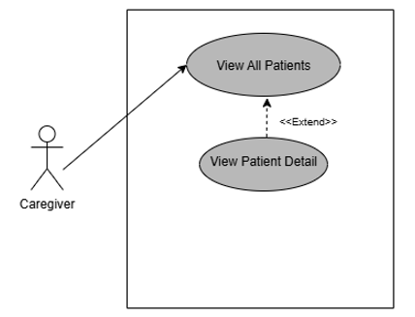

Figure 9 UC-09 View Patients

Figure 9 represents UC-09 which is for caregiver to view all the patients assigned to him.

### 2.6.10 Adnin Login

Figure 10 UC-10 Admin Login

Figure 10 represents UC-10 which is for admin to login using the correct email and password assigned to him.

### 2.6.11 Caregiver registration

Figure 11 UC-11 Caregiver registration

Figure 11 represents UC-11 which is for caregivers to register themselves. Their request is sent to the admin for approval.

### 2.6.12 Registration approval and patient assignment

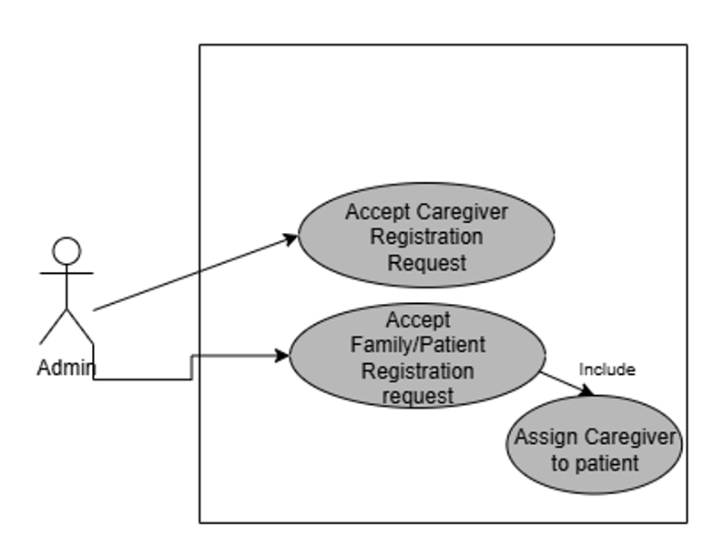

Figure 12 UC-12 Registration approval and patient assignment

Figure 12 represents UC-12 which is for admin to approve a registration request by caregiver and families.

### 2.6.13 View aggregated app insights

Figure 13 UC-13 View aggregated app insights

Figure 13 represents UC-13 which is for admin to view aggregated app insights which include details about app usage and caregivers performance.

### 2.6.14 Family registration

Figure 14 UC-14 family registration

Figure 14 represents UC-14 which is for family to register themselves and their patients. Their requests are sent to the admin for approval.

### 2.6.15 Device Management

Figure 15 UC-15 Device Management

Figure 15 represents UC-15 which is for admin and caregiver to manage the IOT devices.

### 2.6.16 Medication Schedule

Figure 16 UC-16 Medication Schedule

Figure 16 represents UC-16 which is for caregiver to set the medication schedule for each patient. The system sends a notification to the caregiver when it is time for some patient's medication.

## **Software Development life cycle model:**

In our project, we used the Agile model as the Software Development Life Cycle (SDLC) model. Agile suited our team and the system we developed very well. Next, we will talk about why we chose Agile and how we used it in our project.

**Why Agile?**

* **Good for Small Team**: When resources are limited, Agile is a good choice for SDLC. We have a team of three so Agile is well-suited for us, helping us maximize limited resources.
* **Iterative Process**: Agile’s iterative approach lets us work in small, focused stages or “sprints,” each dedicated to specific parts of the project (e.g., real-time data processing, caregiver dashboard, patient behavior analysis, predictive intervention algorithms).
* **Enhanced Collaboration**: Regular team meetings promote close collaboration, ensuring alignment and efficiency in task management.
* **Timely, Incremental Progress**: Agile’s emphasis on steady, incremental progress keeps us on track, supporting our goal to complete the project within the 12-month timeline.
* **Flexibility and Adaptability**: In our project, the development of the advanced monitoring system involves multiple components such as real-time data processing, machine learning algorithms, and integration of multiple data sources.
* **Early and Frequent Testing:** Since our project involves a real-time monitoring system with machine learning algorithms, it’s important to test everything early and often. Agile allows for testing of features as we build them, so we can find and fix problems right away.

**How it was applied in practice?**

**Sprint Planning**: At the start of every sprint, we talked about what we wanted to accomplish during that stage and what tasks we should concentrate on. We divided the project into small manageable sections, created a plan of work correspondingly and made sure that every team member knows what is expected of them during that sprint.

**Role Distribution**:

* One team member focused on frontend development
* Another handled backend processing and system integration
* The third worked on machine learning components and data analysis

**Daily Standups (via group chat)**: We would also give short reports about our progress, ask or answer questions about our progress, and plan the subsequent actions.

**Sprint Reviews & Retrospectives**: After completing each sprint, we reviewed what was accomplished and identified any areas for improvement. This assisted us to keep refining our process of work and adapt when necessary.

# **System design:**

## **Work Breakdown Structure (WBS):**

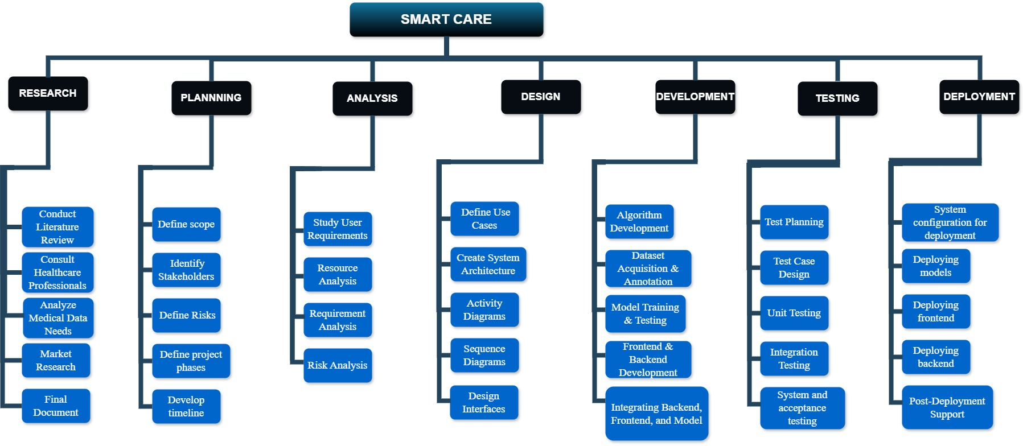

Figure 17 Work Breakdown Structure

## **Activity Diagram:**

### 3.2.1 View Patient Health

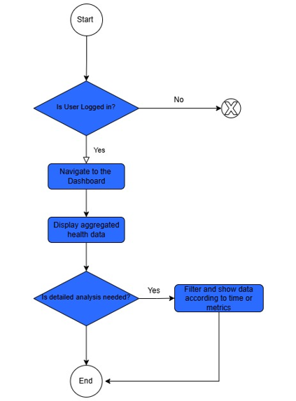

Figure 18 AC-01 View Patient Health Data

Figure 18 represents the flow for viewing the patient health data where if the user is logged in, they are allowed to view the data.

### A diagram of a computer Description automatically generated3.2.2 Caregiver and Family Login

Figure 19 AC-02 Caregiver and Family Login

Figure 19 represents the flow for caregiver and family login where if the entered credentials are valid, the user is logged in

### 3.2.3 Send Query to Caregiver

Figure 20 AC-03 Send Query to Caregiver

Figure 20 represents the flow for a family member to send a query to the caregiver assigned to their patient

### 3.2.4 Send Query to Admin

Figure 21 AC-04 Send Query to Admin

Figure 21 represents the flow for caregiver and family to send a query to admin regarding the technical support they require.

### 3.2.5 View Critical Alerts

Figure 22 AC-05 View Critical Alerts

Figure 22 represents the flow for family members to view the alerts generated by the system for critical events.

### 3.2.6 View and Respond to Queries

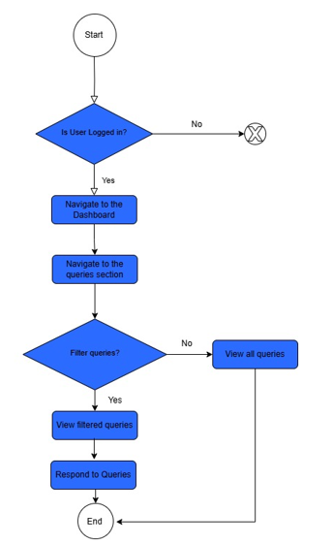

Figure 23 AC-06 View and Respond to Queries

Figure 23 represents the flow for the user to view and respond to queries that has been directed to them.

### 3.2.7 View and Respond to Alerts

Figure 24 AC-07 View and Respond to Alerts

Figure 24 represents the flow for the user to view and respond to alerts that have been created by the system in response to some critical event.

### 3.2.8 Add notes about patients

Figure 25 AC-08 Add Notes about Patients

Figure 25 represents the flow for the caregivers to add notes about the patients to their profiles.

### 3.2.9 View Patients

Figure 26 AC-09 View Patients

Figure 26 represents the flow for the caregiver to view all the patients assigned to him.

### 3.2.10 Admin Login

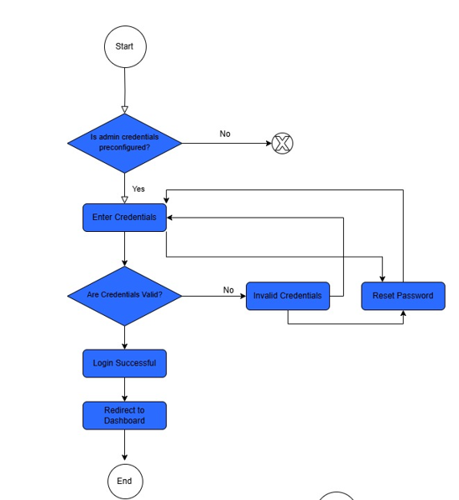

Figure 27 AC-10 Admin Login

Figure 27 represents the flow for the admin to login where if the credentials entered are correct, the admin is redirected to the dashboard.

### 3.2.11 Caregiver and Family Registration

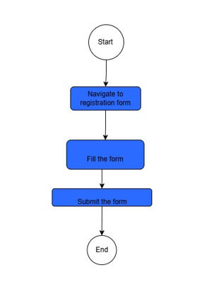

Figure 28 AC-11 Caregiver and Family registration

Figure 28 represents the flow for the caregivers and families to register themselves in the system.

### 3.2.12 Registration Approval and Patient assignment

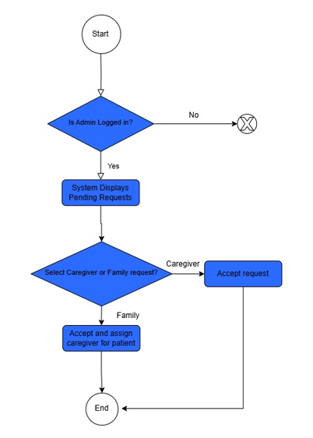

Figure 29 AC-12 Registration approval and patient assignment

Figure 29 represents the flow for the admin to approve the registration requests made by caregivers and families where if the request is from a family, the caregiver is prompted to assign a caregiver to the patient.

### 3.2.13 View Aggregated Insights

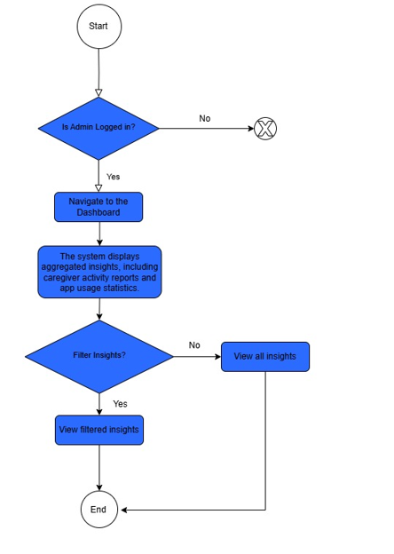

Figure 30 AC-13 View aggregated insights

Figure 30 represents the flow for the admin to view the aggregated app insights which is only possible is he is logged in.

### 3.2.14 Device Management

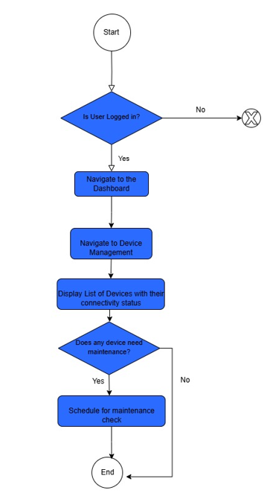

Figure 31 AC-14 Device Management

Figure 31 represents the flow for users to handle device management.

### 3.2.15 Medication Schedule

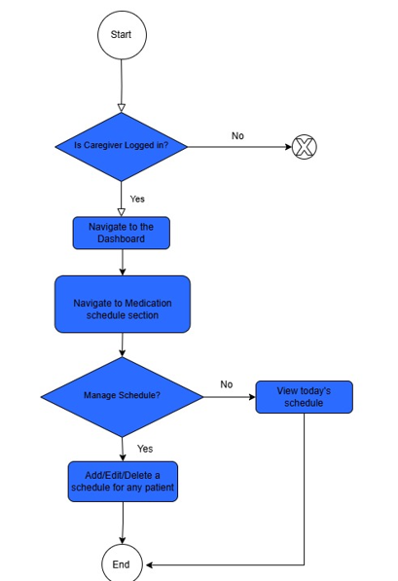

Figure 32 AC-15 Medication Schedule

Figure 32 represents the flow for caregivers to view, assign, edit or delete the medication schedule of a patient

## **Sequence Diagram:**

### 3.3.1 View Patient Health Data

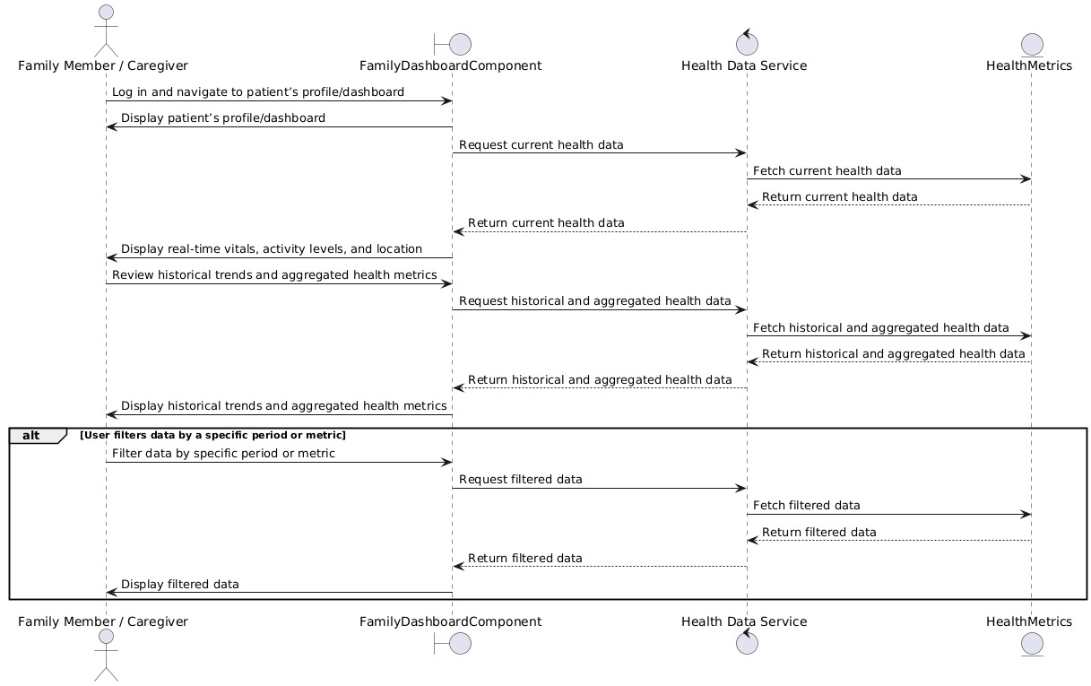

Figure 33 SD-01 View patient health data

Figure 33 represents a sequence diagram which shows how a user can view the patient health data and how the backend retrieves the data from the database and displays it for the user.

### 3.3.2 Caregiver and Family Login

Figure 34 SD-02 Caregiver and family login

Figure 34 represents a sequence diagram which shows how a family member or caregiver can login and how the backend handles the validation of the credentials entered.

### 3.3.3 Send Query to Caregiver

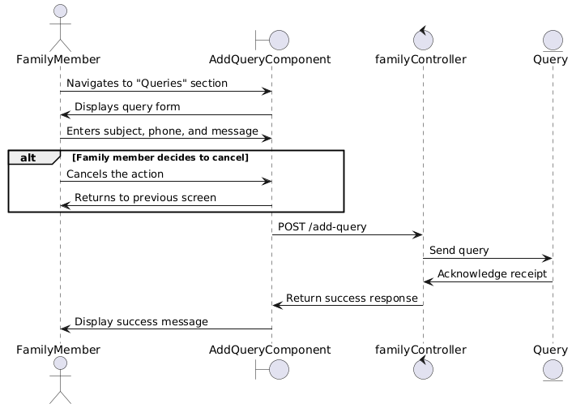

Figure 35 SD-03 Send query to caregiver

Figure 35 represents a sequence diagram which shows how a caregiver can send a query to the admin and how the query is saved to the database.

### 3.3.4 Send Query to Admin

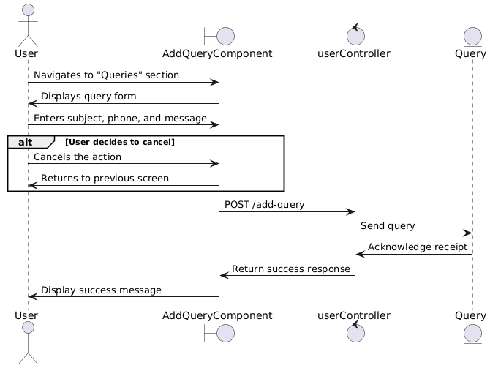

Figure 36 SD-04 Send Query to admin

Figure 36 represents a sequence diagram which shows how a caregiver or a family member can send a query to the admin and how it is saved to the database.

### 3.3.5 View Alerts

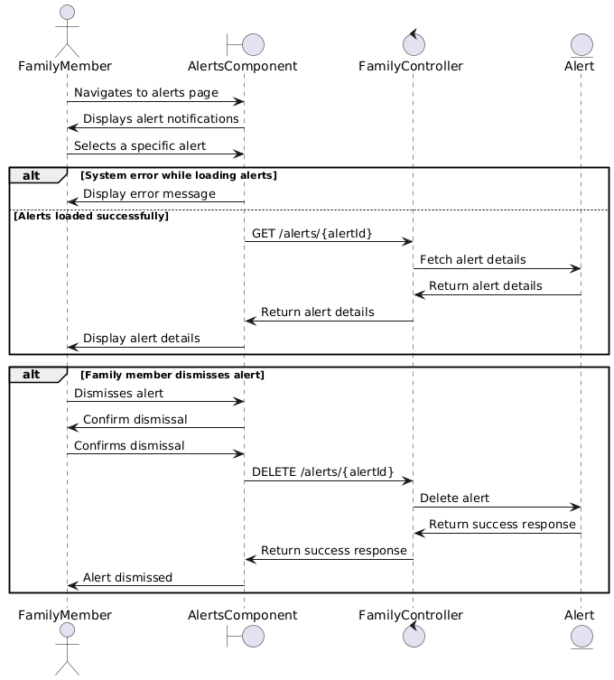

Figure 37 SD-05 View alerts (Family)

Figure 37 represents a sequence diagram which shows how a family member can view the alerts generated by the system for critical events and how they can dismiss it once they have seen it.

### 3.3.6 View and Respond to Query

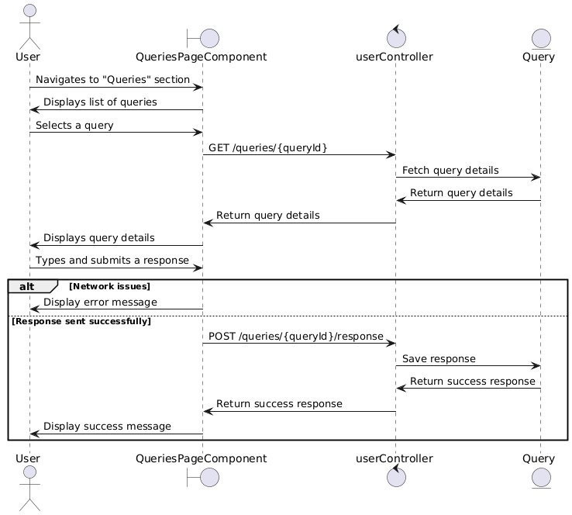

Figure 38 SD-06 View and respond to query

Figure 38 represents a sequence diagram which shows a caregiver and admin can view and respond to the query that are directed to them.

### 3.3.7 View and respond to Alerts

Figure 39 SD-07 View and respond to alerts

Figure 39 represents a sequence diagram which shows how caregivers can view and respond to alerts that have been raised by the system.

### 3.3.8 Add Notes about Patients

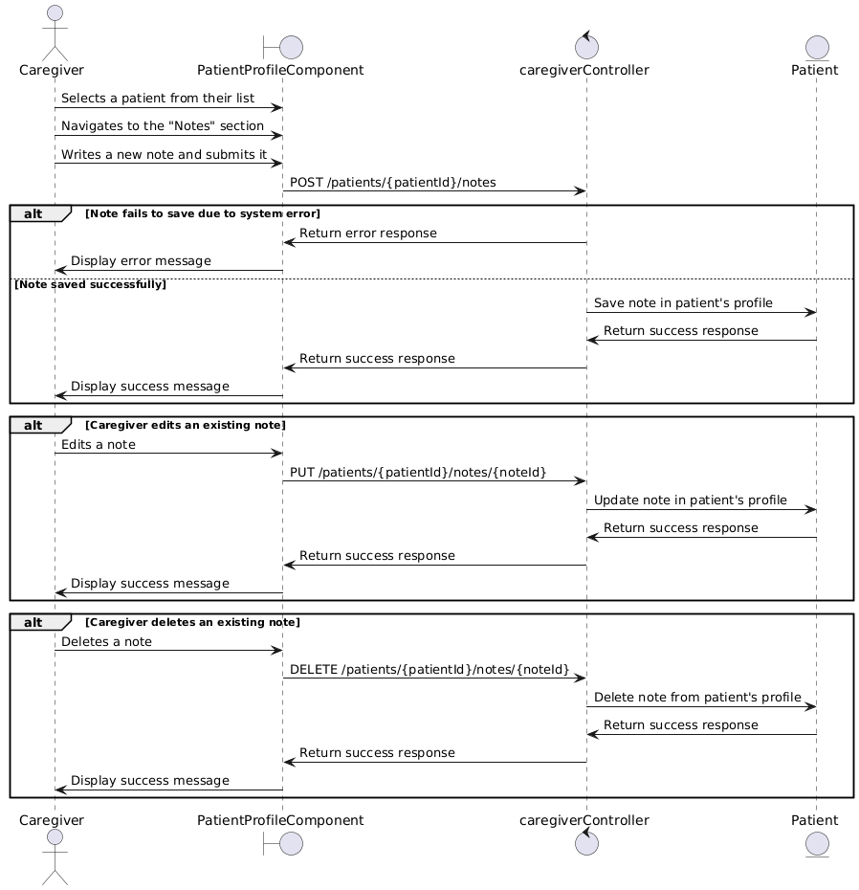

Figure 40 SD-08 Add notes about patients

Figure 40 represents a sequence diagram which shows how a caregiver can add, edit or delete notes about the patients.

### 3.3.9 View Patients

Figure 41 SD-09 View patients

Figure 41 represents a sequence diagram which shows how a caregiver can view the information of all the patients that have been assigned to him.

### 3.3.10 Admin Login

Figure 42 SD-10 Admin Login

Figure 42 represents a sequence diagram which shows how admin can login to the system and how the credentials he entered are validated.

### 3.3.11 Caregiver Registration

Figure 43 SD-11 Caregiver registration

Figure 43 represents a sequence diagram which shows how a caregiver can register himself to the system and how the backend handles this registration.

### 3.3.12 Registration approval and patient assignment

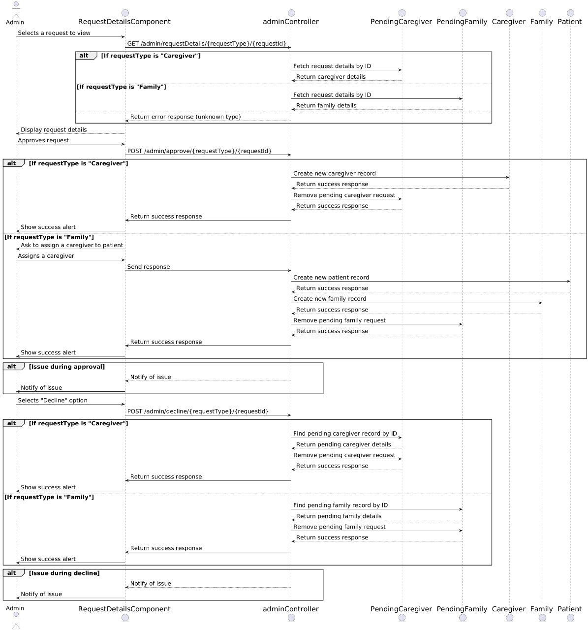

Figure 44 SD-12 Registration approval and patient assignment

Figure 44 represents a sequence diagram which shows how the admin can approve the registration requests made by the caregivers and the family members and how the backend handles this.

### 3.3.13 View Aggregated Insights

Figure 45 SD-13 View aggregated insights

Figure 45 represents a sequence diagram which shows how an admin can view the aggregated app insights and how the backend retrieves it from the backend and display it.

### 3.3.14 Family Registration

Figure 46 SD-14 Family Registration

Figure 46 represents a sequence diagram which shows how a family can register themselves and their patient to the system and how the backend handles this registration process.

### 3.3.15 Device management

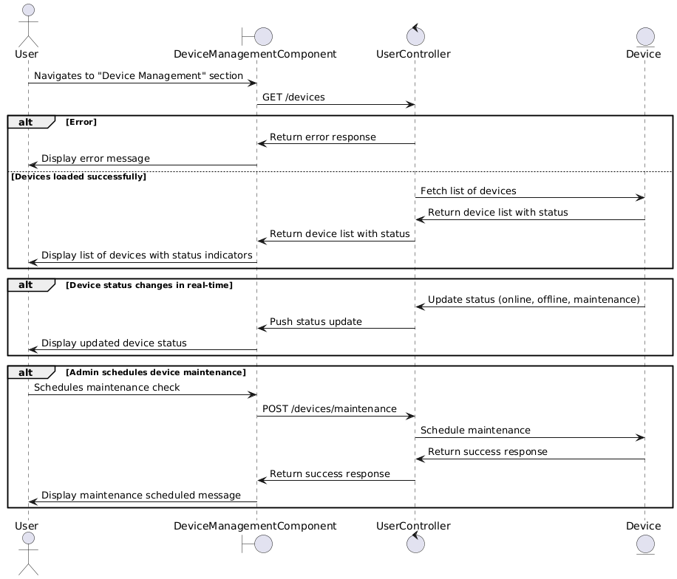

Figure 47 SD-15 Device Management

Figure 47 represents a sequence diagram which shows how the admin and the caregiver can handle device management.

### 3.3.16 Medication Schedule

Figure 48 SD-16 Medication Schedule

Figure 48 represents a sequence diagram which shows how a caregiver can view, add, edit and delete the medication schedule of a patient and how the backend handles these operations.

## **System Architecture:**

Figure 49 System Architecture

The system’s architecture is designed to integrate all sections into a unified mechanism, ensuring a smooth flow of data and their interaction between different modules. Figure 49 demonstrates the proposed architectural design, highlighting both the connections and data pathways necessary for personalized care. Every part is important for achieving the system’s goals, resulting in an advanced solution for elderly care.

### Video based detection and analysis

Video-based monitoring uses the latest technology for real-time monitoring of each individual. The system will detect all the people in the frame and carry out pose estimation and fall detection to guarantee the well-being of each person. Providing unobtrusive monitoring, this module reduces the requirement for wearable devices and improves user comfort.

### Medical data integration from wearables

Wearable devices such as smartwatches provide the medical data. These devices provide information on the stats of the patient’s health. The data may be of physical activity, indicators of stress, and more health-related statistics. Examination of this type of data allows system to identify health problems maintaining a proactive method to healthcare.

### Data analysis and machine learning

The data collected from video cameras and wearable devices are analyzed through advanced data analysis and machine learning techniques. The system preprocesses the data, extracting features and identifying the patterns that influence perception of patient behavior and health status. The effectiveness and accuracy of the system improve due to the adaptation and continuous learning.

### Real-time alerts

The system keeps track of important health signals like heart rate, falls, and unusual behavior in real-time. By watching the person’s movements and monitoring their vital signs, the system is able to quickly spot anything out of the ordinary. If something serious happens, caregivers get an instant alert, so they can respond quickly and help prevent any harm.

### AI-Enhanced injury prevention

AI enhanced injury prevention module plays a crucial role in avoiding injury, hence reducing the risks. System identifies possible dangers such as fall risk by using data from accelerometers and other sensors and provides real-time feedback to reduce the risk.

### Data visualization and reporting

Raw data is transformed into meaningful and valuable insights using data visualization and reporting module, which allow caregivers to see complete view of development of health status. Advanced visualization tools present data into understandable formats, helping with understanding and decision-making. This module supports healthcare experts in the analysis of care plans and making required modifications.

* + 1. **Early detection of Dementia through speech**

Speech data will be used to help detect early signs of dementia through machine learning techniques. By analyzing patterns in a patient’s speech, the system can identify potential cognitive decline and support early diagnosis.

### Dataset Acquisition and Feature Extraction

#### **Health Metrics Dataset:**

This dataset [14] is compiled from a number of fitness tracking devices that provide information about user activity, physical state, and sleep patterns. The data is very much formatted and consists of quantitative data points that can reflect the users’ daily undertakings and health parameters such as heart rate, calories burnt, number of steps, distance, and sleep cycles.

Figure 50 Screenshot of merged dataset of metrics

The dataset aggregates data from different sources or tables into one large dataset for assessment and tracking of health and activity rates. All of them are useful in terms of understanding the user’s physical activity, his or her state of health, and the amount of rest. The combined dataset includes the following:

1. Heart Rate:
   * Real-time recordings of heart rate, typically measured in beats per minute (BPM).
2. Calories Burned:
   * Tracks the number of calories burned over a specified time period.
3. Steps and Distance:
   * Step Count: Records the total number of steps taken by the user, offering a measure of daily activity levels.
   * Distance Covered: Measures the distance traveled, typically derived from step count and stride length. This metric helps quantify movement over time and track progress toward activity goals.
4. Sleep Stages:
   * Divides the user’s sleep into distinct stages, like Deep Sleep, Light Sleep, and Awake.
   * This lets us have a better understanding of sleep quality, patterns, and overall restfulness, which are critical for maintaining mental and physical health.

All these metrics are integrated into one dataset and the system offers a comprehensive view of the user’s daily routine, physical performance, and sleep quality and can thus better track, analyze trends, and offer advice on how the user can improve their health and fitness.

#### **Fall Dataset**

The dataset [15] includes data recorded from a smartwatch (sampling frequency of 50Hz) for elderly fall detection.

The data concerning 8 specific types of falls, each of which was performed three times. These fall types mimic a number of actual cases like falling while walking and falling while sitting. For example:

* F01: A forward fall while walking due to slipping.
* F05: A backward fall while sitting.

Each fall is further detailed with time-stamped phases, which divide the fall event into four key stages:

1. Pre-fall: The period before the fall begins, capturing initial movements or instability.
2. Impact: The moment of contact with the ground or surface.
3. Body Adjustment: Movements made by the body immediately after the impact as it reacts to the fall.
4. Post-fall: The aftermath of the fall, capturing recovery attempts or lack of movement.

This structured dataset offers all the necessary information for a detailed examination of falls, paying particular attention to the sequence and physical traits.

Below are the features used:

Accelerometer (accel_x, accel_y, accel_z)

Gyroscope (gyro_x, gyro_y, gyro_z)

Orientation quaternion (s, i, j, k).

The dataset is built from all patients, which means that all trials and eight types of falls are taken into account. Implementing a single unified approach guarantees coverage of all fall events in different contexts and involving different individuals.

To facilitate analysis and classification, the dataset employs a binary labeling system:

1. Fall events:
   * Assigned a label of 1, indicating that a fall occurred.
   * These labels are based on the timestamps provided for the different phases of the fall (Pre-fall, Impact, Body Adjustment, and Post-fall).
2. Non-fall activities:
   * Assigned a label of 0, representing normal activities where no fall took place.
   * This helps distinguish routine actions from actual fall incidents.

However, when the fall data is merged with the normal activity data the dataset becomes appropriate for training and testing of the machine learning algorithms for fall detection. The labels enable the models to distinguish between the fall episodes and other non-fall events that help in designing effective detection systems.

Feature Scaling:

* Input features normalized using **StandardScaler** for consistent data representation and improved machine learning model performance.

Data Analysis of this is given below:

The graphs given below show the class distribution across the training and testing sets.

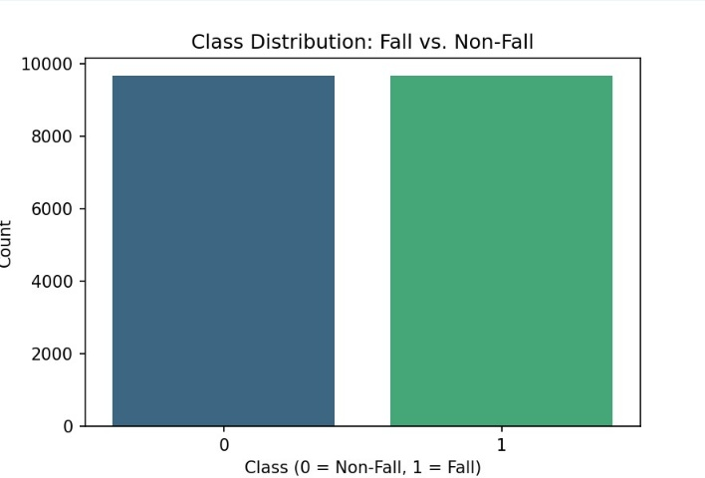

Figure 51 Class Distribution

In addition to this, figure 51 illustrates the balanced class distribution of the Fall (1) and non-fall (0) instances after using Random Oversampling. Currently, both classes have around 10,000 samples in each, which fixes the issue with the initial dataset where non-fall samples were more numerous. This is particularly important in fall detection since the model must be able to learn from both classes equally; otherwise, it could result in poor performance of the model in detecting falls; metrics such as recall, and F1-score will be greatly improved.

Figure 52 Class Distribution is training vs test sets

In Figure 52, it illustrates the chart of the class distribution of “Fall” and “Non-Fall” of the training and test sets. The distributions of the two classes are almost the same in both splits, in which non-fall is the dominant class while Fall is the minority class.

#### **Speech Dataset**

The ADReSS 2020 dataset [16] — an acronym for Alzheimer’s Dementia Recognition through Spontaneous Speech — is a widely used benchmark, designed to assist researchers in the automatic detection of Alzheimer’s disease through natural speech. It involves audio recordings and written transcripts of individuals narrating the classic “Cookie Theft” picture, a staple of cognitive assessments.

What’s interesting about this dataset is that it has speeches from both Alzheimer’s patients as well as control (healthy) groups. The data is carefully balanced by age and gender to reduce bias, and each recording is labeled to support tasks like classifying Alzheimer's vs. control.

The dataset is available for research after you formally request it through the DementiaBank section of the TalkBank portal.

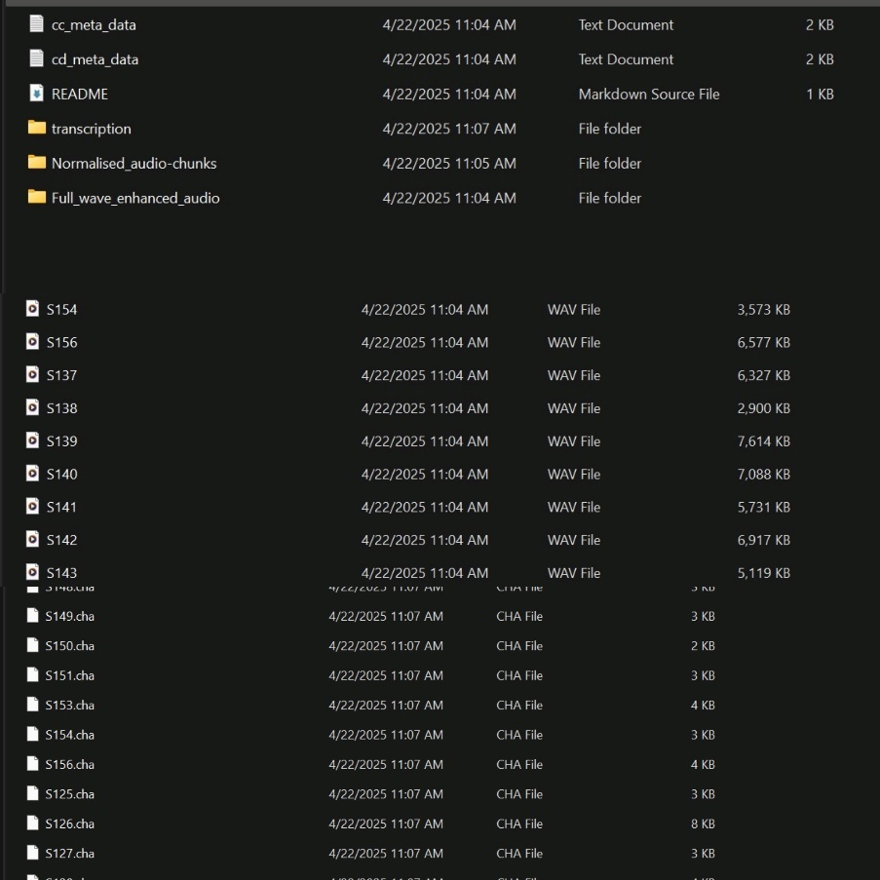

Figure 53 ADReSS 2020 dataset structure with audio recordings, transcripts, and metadata for both Alzheimer’s and control participants.

To support the classification of Alzheimer’s Disease in the ADReSS 2020 dataset, we extracted linguistic and acoustic features from the audio dataset.

**1. Linguistic Features**

These are derived from the text transcripts of the participants' speech using natural language processing (NLP) methods:

* Token and sentence counts
* Mean sentence length
* Part-of-speech (POS) counts (like nouns, verbs, and adjectives)
* Lexical diversity (measured by Type-Token Ratio)

Changes in speech patterns, such as simplified language or reduced vocabulary, are common in Alzheimer's speech. These linguistic features help us track those subtle shifts in how participants use language.

**2. Acoustic Features**

Using audio analysis with librosa, we focus on the sound of speech:

* MFCCs (Mel-frequency cepstral coefficients)
* Chroma (which captures harmonic content)
* Zero-crossing rate (how often the signal crosses zero, indicating articulation)
* Spectral centroid (which shows the "brightness" of the sound)

Alzheimer's can affect vocal quality and speech clarity. These features reveal changes in tone, pitch, and articulation that often occur as the disease progresses.

#### **Datasets for patient recognition, tracking and activity analysis:**

We conducted a controlled experiment with volunteers who gave consent to participate. They performed a series of tasks while being recorded on video. This video data was used to train a face recognition model, and to test patient identification, emotion recognition, and activity recognition models for actions like walking, standing, and sitting.

We also collected individual images of each volunteer and applied data augmentation techniques such as rotation, flipping, scaling, and brightness changes. These images were used to train the face recognition model, while the combined video data supported the other models.

We improved our activity dataset by combining our lab-recorded videos with the ROSE Action Recognition Dataset (also known as NTU RGB+D) [17]. This large public dataset includes over 56,000 video clips (and its extended version has over 114,000 clips) featuring 60 to 120 different actions, captured from 40–106 people, across multiple camera angles, and using RGB, depth, infrared, and skeleton data.

### Machine Learning Models

#### **Fall Detection**

In the case of designing a fall detection system, it is possible to use several machine learning models, which will be discussed below, each of which provides a set of advantages and is suitable for solving different aspects of the problem.

* Logistic Regression is a simple and fast algorithm for binary classification which is why it can be used for fall detection. It assumes that the input features such as accelerometer and gyroscope have a direct proportional relationship with the probability of a fall event. This simplicity makes the model interpretable since the coefficients represent the weight of each feature, thus offering understanding of aspects of fall detection. Besides, it is computationally efficient to perform real-time predictions with a low consumption of resources. However, it may be less effective to identify intricate and nonlinear structures that exist in the data.
* XGBoost is a fast and efficient boosting algorithm, considered being one of the best ensemble methods to work with big data. Since, gradient boosting works by iteratively targeting the misclassification of instances, it is suitable for imbalanced scenario such as fall detection. XGBoost can capture nonlinear relationship between features and outputs and hence it will give accurate prediction even in the case of complex relationship between the data. It does not overfit, and its feature importance abilities allow selecting the most important predictors. XGBoost is slightly slower than other boosters but the latter’s high accuracy makes it suitable for subtle patterns in falls.
* Random Forest is an effective ensemble learning model, which has several decision trees and takes a voting system to classify objects. It performs best in cases of non-linear and complex data and in data with different numbers and types of features, including accelerometer, gyroscope, and orientation in the case of fall detection. The model does not suffer from overfitting even in noisy or imbalanced datasets; moreover, it delivers information about the features’ importance, which helps to address the dataset. Even though it is more computationally intensive than other models, the ability to model interactions between features makes it a suitable model for detecting a large number of fall scenarios.

Table 41 Result of Models

|  |  |  |  |  |
| --- | --- | --- | --- | --- |
| Model | Accuracy | Precision | Recall | F1-Score |
| Random Forest | 0.92 | 0.90 | 0.95 | 0.93 |
| Logistic Regression | 0.58 | 0.60 | 0.53 | 0.57 |
| XGBoost | 0.87 | 0.87 | 0.87 | 0.87 |

Figure 54 Feature Importance Comparison in Random Forest and XGBoost

Figure 55 Confusion Matrices

Figure 56 Comparison of Model performance

Random Forest was selected as the final model because it yields the highest accuracy of 83.53% and capability to handle multiple fall situations. It is consistent and reliable and, by virtue of the ensemble approach, captures intricate details of the data. Further, it offers information about features’ significance; thus, it is the best and most explainable model for the fall detection system.

#### **Stress Detection Using Heart Rate Variability (HRV)**

The method used for stress detection in this project is based on the research paper titled:

Stress Management through Heart Rate Variability as a Human Resource Management Strategy by Bukhari Shafiq Bin Asnain, Siew-Chin Chong, Kuok-Kwee Wee [18].

This work offered a solid framework to assess the stress level, as well as the HRV Triangular Index derived from the heart rate.

We utilized the heart rate data obtained at the per second level from wearable devices such as smartwatches or heart rate monitors.

Each reading is the number of heart beats per minute (BPM) recorded at one second interval.

Data collected over some specific time was used to calculate HRV over a period of time.

The HRV Triangular Index was calculated using the formula:

Figure 57 Formula for HRV Triangular Index

NN intervals: Time intervals between consecutive normal heartbeats.

Sum of NN intervals: Total count of intervals over the period.

Max NN Interval: The most frequent NN interval in the dataset.

The obtained HRV Triangular Index values were referred to stress levels according to the description given in the paper cited above. The classification is as follows:

Table 42 Category of Stress Level based on HRV

|  |  |
| --- | --- |
| Heart Rate Variability Triangular Index | Stress Level |
| 2-15 | Highly Tense |
| 16-25 | Slightly Tense |
| 26-52 | Mildly Calm |
| 53-60 | Quietly Relaxed |
| >60 | Deeply Relaxed |

#### **Detection of Dementia through speech**

We investigated three widely used machine learning classification methods which included Support Vector Machine (SVM), Random Forest and XGBoost. The main goal was to determine which model delivered optimal results among available options using extracted dataset features. The small dataset size made deep learning models inappropriate because they overfit limited training data while needing extensive computational power. We selected traditional machine learning models because they prove to be most suitable and efficient for working with smaller datasets.

* Support Vector Machine with a linear kernel was applied first. SVM is particularly effective for binary classification problems and performs well in high-dimensional spaces. It achieved a moderate level of accuracy (72.7%) and showed balanced performance across both classes. However, its lower recall for detecting dementia cases made it less ideal for this specific medical application, where identifying positive cases is critical.
* The ensemble method with numerous decision trees surpassed the performance of SVM. All evaluation metrics maintained consistency as the overall accuracy reached 81.8% across the experiment. The ability of Random Forest to handle numerical and categorical inputs and resist overfitting makes it an ideal model for datasets with our structure.
* Among the tested models XGBoost (Extreme Gradient Boosting) produced the highest performing results. XGBoost earned recognition due to its fast computational speed together with advanced data pattern recognition capabilities and intrinsic overfitting prevention measures through regularization capabilities. XGBoost enhances itself through a strategic step-by-step learning process which uses previous mistakes to create improved prediction accuracy. The strengths of XGBoost led to its selection as the most suitable model for detecting dementia because of its reliable performance.

Table 43 Result of models for Dementia Detection

|  |  |  |  |  |
| --- | --- | --- | --- | --- |
| Model | Accuracy | Precision | Recall | F1-Score |
| SVM | 0.50 | 0.25 | 0.50 | 0.33 |
| Random Forest | 0.68 | 0.70 | 0.68 | 0.68 |
| XGBoost | 0.86 | 0.89 | 0.86 | 0.86 |

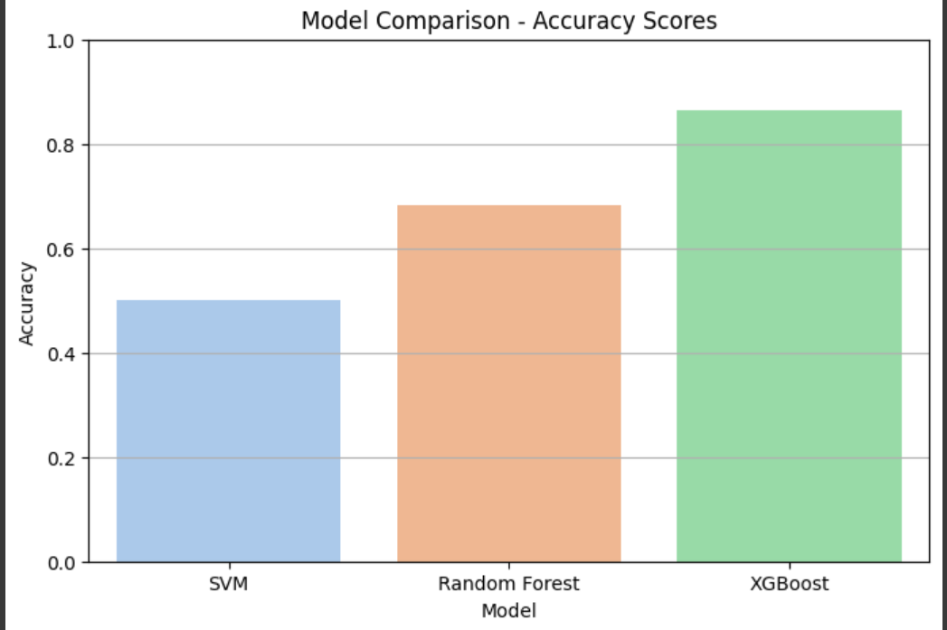

Figure 58 Comparison of models used

#### **Patient identification, tracking and activity analysis:**

A series of state-of-the-art deep learning models were selected to perform patient recognition, emotional state detection, and activity analysis. The models were chosen based on their accuracy, efficiency, and real-time performance capabilities, ensuring the system's reliability in practical healthcare scenarios.  
The overall process flow is as follows:

##### **3.4.9.4.1 Face Detection — MTCNN**

The first step is to detect faces within the video frames. For this, the Multi-task Cascaded Convolutional Networks (MTCNN) was utilized.

* Reason for Selection:
  + High accuracy in detecting faces across a range of poses and lighting conditions.
  + Robust performance in the presence of occlusions and partial visibility.
  + Fast processing speed, making it suitable for near real-time applications.

MTCNN detects both the facial bounding box and key facial landmarks, which are essential for accurate downstream tasks like recognition and emotion analysis.

##### **3.4.9.4.2 Face Recognition — FaceNet**

Once faces are detected, FaceNet is employed to generate embeddings — compact numerical representations of each face. These embeddings are used for identifying and verifying individuals.

* Reason for Selection:
  + Robustness: FaceNet creates highly discriminative embeddings, ensuring accurate recognition even under variations in facial expressions, orientations, and lighting conditions.
  + Scalability: Capable of handling large datasets without significant loss in performance, making it suitable for tracking multiple individuals over time.

FaceNet allows the system to consistently recognize patients across different video frames and sessions. We used our own dataset that we made to train this model and achieved these results.

Table 44 Classification report for model performance

|  |  |  |  |  |
| --- | --- | --- | --- | --- |
| Class | Precision | Recall | F1-Score | Support |
| Class 1 | 1.00 | 1.00 | 1.00 | 23 |
| Class 2 | 1.00 | 1.00 | 1.00 | 23 |
| Class 3 | 1.00 | 1.00 | 1.00 | 22 |
| Accuracy |  |  | **1.00** | 68 |
| Macro Avg | 1.00 | 1.00 | 1.00 | 68 |
| Weighted Avg | 1.00 | 1.00 | 1.00 | 68 |

The 100% accuracy in the face-recognition pipeline can be attributed to three main factors. First, the use of highly discriminative embeddings from the pre-trained FaceNet model ensures that each face is represented as a 512-dimensional vector, where images of the same person are mapped close together and images of different people are far apart, making the vectors almost perfectly separable. Second, the strong, clean dataset of clear, well-lit, front-facing images with stratified splits ensures that the training and test sets share the same distribution, minimizing noise and occlusion. Finally, the effective classifier choice of a linear SVM on these embeddings creates a high-margin hyperplane that cleanly separates the individuals’ clusters, resulting in no misclassification on held-out images. Together, these factors lead to perfect accuracy in controlled conditions, though real-world scenarios with noisy images or new identities might see a drop in performance.

##### **3.4.9.4.3 Emotion Detection — DeepFace**

After recognizing the individual, the system assesses their emotional state using DeepFace. DeepFace applies pre-trained deep learning models to detect and classify facial emotions such as happiness, sadness, anger, surprise, etc.

* Reason for Selection:
  + Pre-trained Efficiency: DeepFace eliminates the need for extensive training, allowing for immediate and reliable emotion classification.
  + High Accuracy: It is one of the leading frameworks for emotion recognition from facial features, providing dependable predictions in real-time.

Emotion detection is particularly important in patient monitoring to assess their mental and emotional well-being over time.

##### **3.4.9.4.4 Person Detection — YOLOv8n**

Parallel to facial analysis, person detection is performed using YOLOv8n, a lightweight yet powerful object detection model optimized for speed and real-time inference.

* Reason for Selection:
  + Real-Time Performance: YOLO architecture is renowned for its ability to detect objects with minimal delay.
  + Efficiency: The *nano* version (YOLOv8n) strikes an optimal balance between speed and accuracy, making it ideal for applications where low latency is critical.

Person detection is used to locate and continuously track patients within a larger scene, even when their face is not fully visible. Once a person’s face has been recognized, it is essential to "lock" onto them to maintain consistent tracking, even if they turn their back toward the camera or their face is temporarily obscured. By integrating person detection, the system ensures robust, uninterrupted tracking after the initial facial recognition event.

##### **3.4.9.4.5 Activity Monitoring — MediaPipe Pose**

MediaPipe Pose is employed to estimate full-body poses by identifying key joints such as shoulders, elbows, hips, and knees. Instead of analyzing isolated poses, the system monitors sequences of poses over time to recognize and classify activities like walking, standing, sitting, or detecting falls. This temporal analysis of pose sequences enables accurate activity recognition critical for continuous patient monitoring.

We leverage the real-time, high-precision capabilities of MediaPipe to capture dynamic movements without noticeable lag, providing robust data for downstream analysis. By tracking changes and transitions in body posture and movement patterns, the system can infer the patient’s current activity and generate a detailed activity timeline.

##### **3.4.9.4.6 Behavior Analysis:**

To enhance the understanding of patient behavior, data from wearable devices (e.g., accelerometers, heart rate monitors) is combined with video-based pose estimation outputs. This multimodal data integration creates a comprehensive daily routine profile for each patient.

The system stores and updates these daily activity routines over multiple days, continuously adding the most recent data while discarding older records to maintain a relevant time window. We used Long Short-Term Memory (LSTM) neural networks as they are well suited for sequential time series data. The system trains models on these routines to learn typical behavior patterns.

This ongoing training process allows the system to detect anomalies or deviations from normal behavior patterns in near real-time, providing early warnings for potential health or safety concerns. This adaptive behavior analysis helps healthcare providers monitor patients more effectively, ensuring timely interventions when unusual activity is detected.

Each model was carefully selected to optimize both performance and speed, ensuring that the integrated system can function effectively in real-world healthcare monitoring environments. This modular approach allows future upgrades, where models can be swapped or enhanced independently as new technologies emerge.

### FRONTEND:

**3.4.10.1 Start Screen /Login Screen:**

Figure 59 Start Screen

Figure 60 Login Screen

#### **3.4.10.2 Registration screens:**

Figure 61 Caregiver Registration

Figure 62 Family registration

#### **3.4.10.3 Forgot Password:**

Figure 63 Forgot Password

Figure 64 OTP Code

Figure 65 Reset Password

#### **3.4.10.4 Admin Dashboard:**

Figure 66 Admin Dashboard (1)

Figure 67 Admin Dashboard (2)

#### **3.4.10.5 Family Dashboard:**

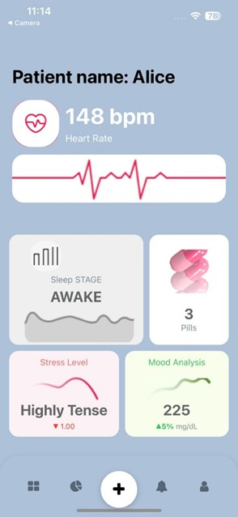

Figure 68 Family Dashboard (1)

Figure 69 Family Dashboard (2)

#### **3.4.10.6 Caregiver Dashboard:**

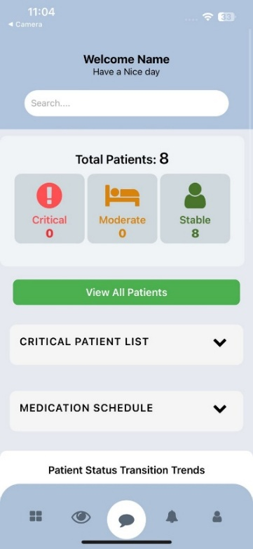

Figure 70 Caregiver Dashboard (1)

Figure 71 Caregiver Dashboard (2)

#### **3.4.10.7 Pending Request for Registration Handling:**

Figure 72 Pending Requests

Figure 73 Request Details

#### **3.4.10.8 Alerts:**

Figure 74 Alerts

#### **3.4.10.9 Queries:**

Figure 75 Add Query

Figure 76 My queries (Caregiver and Admin)

#### **3.4.10.10 View Users and Details:**

Figure 77 View Users

Figure 78 User Details

#### **3.4.10.11 Medication:**

Figure 79 Add medication

Figure 80 Medication schedule

### BACKEND:

* + - 1. **Node.js API**
* Role: Serves as the point of application functionality where all CRUD operations are handled and where it communicates with the mobile application as well as other backend services.
* Key Functionality: Forwards specific requests to the FastAPI server while managing application logic as well as managing user data.
  + - 1. **FastAPI**
* Role: Utilizes machine learning models in the React Native app to give accurate and fast prediction or information.
* Key Functionality: Responsible for carrying out ML-related activities and integrating processes while guaranteeing fast response time for the predictive analysis and intelligent features.
  + - 1. **Technology Stack**
* Express.js: Used for routing and for connecting to middleware within Node.js API.
* FastAPI: It has inbuilt validation and high performance for handling machine learning model integration.
* PostgreSQL: A reliable relational database management system for structured data and for performing complex queries.
* React Native: Used for front end development.

## **Class diagram:**

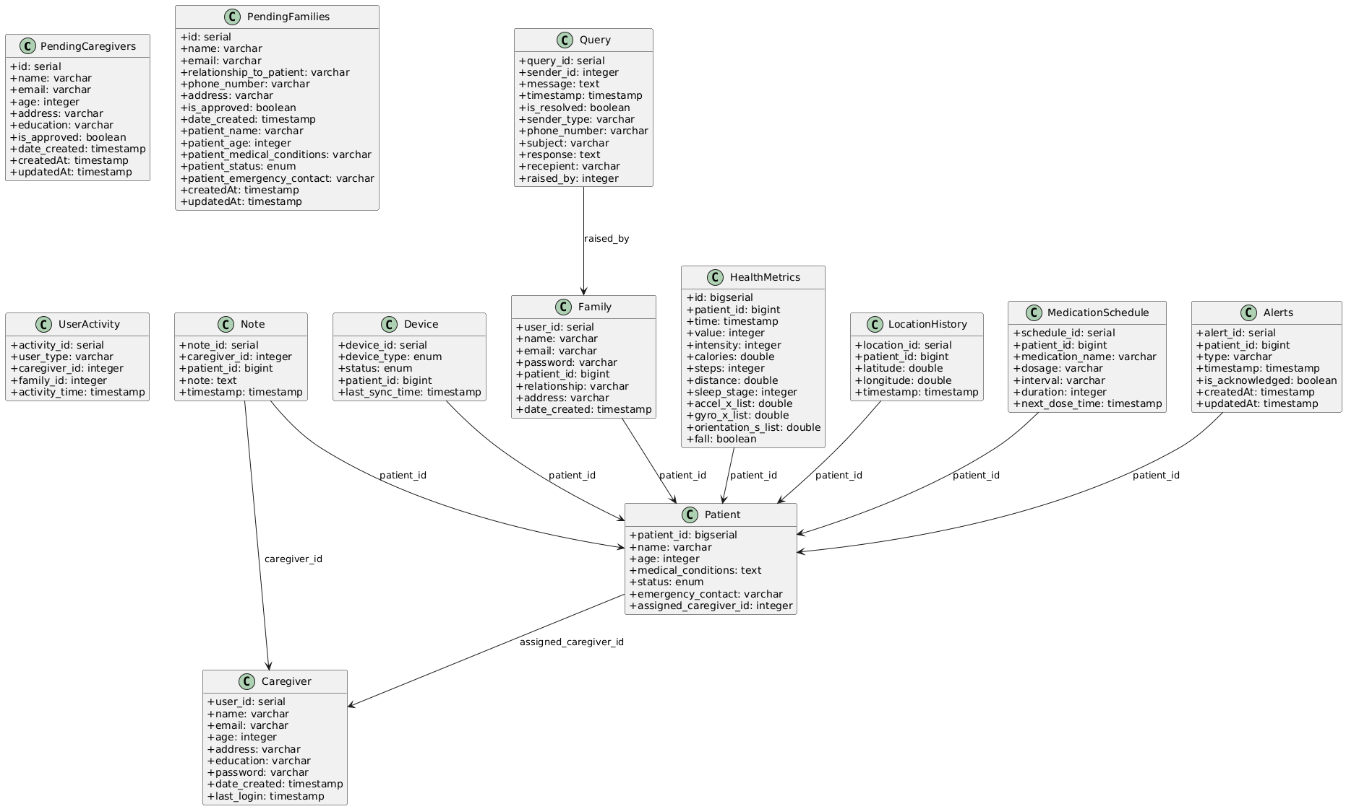

Figure 81 Class Diagram

Figure 81 describes the database entity-relationship model for the patient care management system, showing entities such as caregivers, patients, families, devices, health metrics, alerts, and related tables, along with their attributes and relationships for storing, managing, and linking patient care data.

## **Database diagram:**

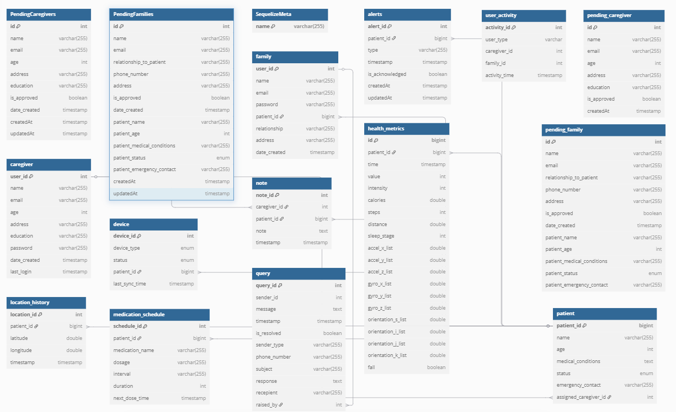

Figure 82 Database Diagram

Figure 82 describes the database entity-relationship model for the patient care management system, showing entities such as caregivers, patients, families, devices, health metrics, alerts, and related tables, along with their attributes and relationships for storing, managing, and linking patient care data.

# **System Testing:**

## **Test Cases**

### TC-01

Table 45 TC-01 View Patient Health Data

|  |  |
| --- | --- |
| **Test Case ID** | **TC-01** |
| **Test Case Title** | View Patient Health Data |
| **Description** | Check that real-time and historical patient health data are displayed correctly. |
| **Preconditions** | User is logged into the system. |
| **Test Steps** | Navigate to the patient dashboard.  Review real-time vitals and activity data.  Check aggregated metrics such as averages. |
| **Expected Results** | Real-time and aggregated health data are displayed accurately. |
| **Actual Results** | Real-time vitals and activity data loaded correctly. |
| **Status** | Pass |

Table 45 describes the test case TC-01, verifying that real-time and historical patient health data are displayed accurately on the dashboard.

### TC-02

Table 46 TC-02 Family/Caregiver Login

|  |  |
| --- | --- |
| **Test Case ID** | **TC-02** |
| **Test Case Title** | Family/Caregiver Login |
| **Description** | Check that family or caregiver can log in with valid credentials. |
| **Preconditions** | User is registered in the system. |
| **Test Steps** | Enter username and password.  Click "Login." |
| **Expected Results** | User is redirected to the dashboard. |
| **Actual Results** | User successfully logged in and was redirected to the dashboard. |
| **Status** | Pass |

Table 46 describes the test case TC-02, verifying that family members and caregivers can log in with valid credentials and access their dashboard.

### TC-03

Table 47 TC-03 Send Query to Caregiver

|  |  |
| --- | --- |
| **Test Case ID** | **TC-03** |
| **Test Case Title** | Send Query to Caregiver |
| **Description** | Validate that family members can submit queries to caregivers. |
| **Preconditions** | User is logged into the system. |
| **Test Steps** | Navigate to the “Queries” section.  Enter query details and submit. |
| **Expected Results** | Query is sent successfully and logged. |
| **Actual Results** | Query was successfully sent and logged in the system. |
| **Status** | Pass |

Table 47 describes the test case TC-03, verifying that family members can send queries to caregivers and have them logged in the system.

### TC-04

Table 48 TC-04 Send Query to admin

|  |  |
| --- | --- |
| **Test Case ID** | **TC-04** |
| **Test Case Title** | Send Query to Admin |
| **Description** | Validate submission of technical support queries to the admin. |
| **Preconditions** | User is logged into the system. |
| **Test Steps** | Navigate to the “Queries” section.  Enter query details and submit. |
| **Expected Results** | Query is sent successfully and logged. |
| **Actual Results** | Query was successfully sent and logged in the system. |
| **Status** | Pass |

Table 48 describes the test case TC-04, verifying that users can send technical support queries to the admin and have them logged.

### TC-05

Table 49 TC-05 View alerts for critical events

|  |  |
| --- | --- |
| **Test Case ID** | **TC-05** |
| **Test Case Title** | View Alerts for Critical Events |
| **Description** | Ensure alerts for critical events are displayed correctly. |
| **Preconditions** | A critical alert is triggered. |
| **Test Steps** | Open the dashboard.  View the list of alerts.  Select an alert to view details. |
| **Expected Results** | Alert details (cause, time, response) are displayed. |
| **Actual Results** | The alert appeared in the dashboard immediately after being triggered. |
| **Status** | Pass |

Table 49 describes the test case TC-05, verifying that alerts for critical events are displayed with accurate details such as cause, time, and response.

### TC-06

Table 50 TC-06 Reply to Query

|  |  |
| --- | --- |
| **Test Case ID** | **TC-06** |
| **Test Case Title** | Reply to Query |
| **Description** | Validate that caregivers and admins can respond to queries. |
| **Preconditions** | Query exists in the system. |
| **Test Steps** | Open the “Queries” section.  Select a query.  Type and submit a response. |
| **Expected Results** | Response is sent successfully. |
| **Actual Results** | Response was successfully sent and logged in the system. |
| **Status** | Pass |

Table 50 describes the test case TC-06, verifying that caregivers and admins can reply to queries and have responses logged in the system.

### TC-07

Table 51 TC-07 Add notes about patients

|  |  |
| --- | --- |
| **Test Case ID** | **TC-07** |
| **Test Case Title** | Add Notes About Patients |
| **Description** | Validate that caregivers can add notes to a patient's profile. |
| **Preconditions** | Caregiver is logged in. |
| **Test Steps** | Select a patient.  Go to the "Notes" section.  Write and save a note. |
| **Expected Results** | Note is saved and available for future reference. |
| **Actual Results** | Note was successfully written, saved, and displayed in the patient's profile. It remained accessible upon returning to the "Notes" section. |
| **Status** | Pass |

Table 51 describes the test case TC-07, verifying that caregivers can add notes to a patient’s profile and retrieve them for future reference.

### TC-08

Table 52 TC-08 Respond to critical alerts

|  |  |
| --- | --- |
| **Test Case ID** | **TC-08** |
| **Test Case Title** | Respond to Critical Alerts |
| **Description** | Validate that caregivers can respond to critical alerts. |
| **Preconditions** | Critical alert is generated. |
| **Test Steps** | View notification for a critical alert.  Review alert details.  Log an appropriate response. |
| **Expected Results** | Response is logged successfully. |
| **Actual Results** | Fall detection was triggered by the model, and a critical alert was sent to the caregiver. Similarly, alerts were triggered when health data showed elevated stress levels and high heart rate, which were also logged and sent as critical alerts. The caregiver successfully reviewed the alerts and logged appropriate responses. |
| **Status** | Pass |

Table 52 describes the test case TC-08, verifying that caregivers can respond to critical alerts and have responses logged successfully.

### TC-09

Table 53 TC-09 View all patients

|  |  |
| --- | --- |
| **Test Case ID** | **TC-09** |
| **Test Case Title** | View All Patients |
| **Description** | Ensure the patient list and detailed profiles are accessible. |
| **Preconditions** | Caregiver is logged in. |
| **Test Steps** | Navigate to the "Patient List."  Select a patient to view detailed data. |
| **Expected Results** | Patient list and details are displayed correctly. |
| **Actual Results** | Patient list displayed successfully. Detailed data for each selected patient loaded accurately without delays or errors. |
| **Status** | Pass |

Table 53 describes the test case TC-09, verifying that caregivers can view the patient list and access detailed profiles without errors or delays.

### TC-10

Table 54 TC-10 Admin login

|  |  |
| --- | --- |
| **Test Case ID** | **TC-10** |
| **Test Case Title** | Admin Login |
| **Description** | Validate admin login with preconfigured credentials. |
| **Preconditions** | Admin account exists. |
| **Test Steps** | Navigate to the login page.  Enter admin credentials and click "Login." |
| **Expected Results** | Admin dashboard loads successfully. |
| **Actual Results** | Admin logged in successfully. Admin dashboard loaded without errors. |
| **Status** | Pass |

Table 54 describes the test case TC-10, verifying that admins can log in with valid credentials and access the admin dashboard.

### TC-11

Table 55 TC-11 Caregiver Registration Form Submission

|  |  |
| --- | --- |
| **Test Case ID** | **TC-11** |
| **Test Case Title** | Caregiver Registration Form Submission |
| **Description** | Validate submission of caregiver registration forms. |
| **Preconditions** | Caregiver is not registered. |
| **Test Steps** | Access the registration form.  Complete and submit the form. |
| **Expected Results** | Form is submitted for admin review. |
| **Actual Results** | Registration form submitted successfully. Confirmation message displayed: *"Your registration form has been submitted for review by the admin."* |
| **Status** | Pass |

Table 55 describes the test case TC-11, verifying that caregivers can submit registration forms for admin review.

### TC-12

Table 56 TC-12 Approve registrations

|  |  |
| --- | --- |
| **Test Case ID** | **TC-12** |
| **Test Case Title** | Approve Registrations |
| **Description** | Validate approval of caregiver and family registrations. |
| **Preconditions** | Admin is logged in. |
| **Test Steps** | Navigate to "Registration Requests."  Approve caregiver and family requests. |
| **Expected Results** | Registrations are approved successfully. |
| **Actual Results** | Registrations approved successfully. The system updated the user statuses, and confirmation messages along with their passwords were sent to them. |
| **Status** | Pass |

Table 56 describes the test case TC-12, verifying that admins can approve caregiver and family registrations and notify them accordingly.

### TC-13

Table 57 TC-13 View aggregated insights

|  |  |
| --- | --- |
| **Test Case ID** | **TC-13** |
| **Test Case Title** | View Aggregated Insights |
| **Description** | Validate that aggregated app insights are displayed. |
| **Preconditions** | Admin is logged in. |
| **Test Steps** | Open the dashboard.  Review aggregated caregiver activity and system usage data. |
| **Expected Results** | Insights are displayed correctly. |
| **Actual Results** | Pending |
| **Status** | Pending |

Table 57 describes the test case TC-13, verifying that aggregated caregiver activity and system usage insights are displayed in the dashboard.

### TC-14

Table 58 TC-14 Family Registration Form Submission

|  |  |
| --- | --- |
| **Test Case ID** | **TC-14** |
| **Test Case Title** | Family Registration Form Submission |
| **Description** | Validate submission of family registration forms. |
| **Preconditions** | Family is not registered. |
| **Test Steps** | Access the registration form.  Complete and submit the form. |
| **Expected Results** | Form is submitted for admin review. |
| **Actual Results** | Form submitted successfully. A confirmation message displayed: *"Your registration form has been submitted and is pending admin approval."* The form entry was recorded in the "Registration Requests" section for admin review. |
| **Status** | Pass |

Table 58 describes the test case TC-14, verifying that families can submit registration forms for admin review.

### TC-15

Table 59 TC-15 Manage Connected Devices

|  |  |
| --- | --- |
| **Test Case ID** | **TC-15** |
| **Test Case Title** | Manage Connected Devices |
| **Description** | Validate that devices can be managed and monitored. |
| **Preconditions** | Devices connected to the system. |
| **Test Steps** | Open the "Device Management" section.  Review device statuses.  Update device settings if necessary. |
| **Expected Results** | Device statuses and updates are displayed. |
| **Actual Results** | Device statuses loaded correctly. Updates to device settings were applied without errors and reflected in the system in real-time. |
| **Status** | Passed |

**Table 59** describes the test case TC-15, verifying that connected devices can be monitored, updated, and managed in real-time.

### TC-16

Table 60 TC-16 Manage Medication Reminders

|  |  |
| --- | --- |
| **Test Case ID** | **TC-16** |
| **Test Case Title** | Manage Medication Reminders |
| **Description** | Validate addition and management of medication reminders. |
| **Preconditions** | Caregiver logged into the system. |
| **Test Steps** | Navigate to a patient’s profile  Add a new reminder.  Edit and delete existing reminders. |
| **Expected Results** | Reminders are managed successfully. |
| **Actual Results** | System successfully allowed addition, editing, and deletion of medication reminders without errors. Changes were reflected correctly in the patient's profile. |
| **Status** | Passed |

Table 60 describes the test case TC-16, verifying that caregivers can add, edit, and delete medication reminders for patients.

## **Unit Testing**

Unit testing means checking each small part of the system to ensure it works correctly. It’s like looking at each puzzle piece to make sure it fits perfectly.

### Test Cases:

System integration testing – this is also known as integration testing or system level testing is defined as the testing of each small part of the system to check whether it is in order. In terms of puzzles, one does not look at each piece to ensure it aligns with the other piece. In unit testing specific tests are developed to determine how the tiny components of the system function. For instance, in the “Smart Care” system, unit testing consists of checking certain functionalities such as gathering health information, signaling or modifying a patient’s records. Some of the questions that could be tested are exemplified by correct and incorrect alarms or ways of handling errors in data received from sensors, or appropriate ways of processing the patient data. Therefore, the objective is to achieve problem-solving in each of them so that nothing is unresponsive or nonfunctional. It’s like looking at each puzzle piece to make sure it fits perfectly.

### Benefits:

* **Finding Problems Early:** Unit testing is very useful because it enables a programmer to pick any one part and find out that it does not work as it should.
* **More Reliable System:** It also makes each of the pieces to work as intended, making the whole platform much more reliable.
* **Easier Problem Solving:** When individual pieces are tested the defects are easier to identify and corrected if there are any.
* **Safe Updates:** Unit tests allow developers to add or change some elements of the system without harming the rest of the system.
* **Clear Documentation:** This is similar to having a plan or a map that one uses to know how a certain component of a system should function.
* **Time-Saving:** Unit tests can be effective in the automated environment where it is easily detectable if newly developed changes have some effects on the progress.
* **Lower Costs:** One has to remember that corrective action costs less and takes less time than corrective action at a later stage

## **Integration Testing**

Integration testing verifies the compatibility of the pieces of a system. It’s like making sure all the instruments in an orchestra play in harmony.

### Test Cases:

* Integration testing focuses on the data movement and interaction between different elements of the system, such as the sensors, the AI tools and the caregivers’ dashboards.
* For instance, it evaluates the input of heart rate data from the wearables as well as how the AI interprets and displays it on the dashboard.
* It also refers to situations where the data is disrupted, the incompatibility of the format involved or when there is a failure in synchronizing between elements

### Benefits:

* **Testing Connections:** Makes sure that there is an effective interaction between the system parts as well as performance as envisaged.
* **Finding Hidden Issues:** Promotes detection of issues that may likely not be disclosed by unit testing and can only be seen when work from several units is integrated.
* **Smooth Experience:** Ensures that the data moves well and gives the caregivers and patients good experience.
* **Avoid Future Problems:** To sum it up, use integration points to plan and address integration problems in advance avoiding large scale disruptions later.
* **Better Quality:** Enhances the system quality because it shows how the sub systems integrate within the whole system.
* **Cost-Effective Fixes:** This means that solving these difficulties in the process of development will be less expensive than during the stage of creating a site.

## **System Testing**

System testing on the other hand focuses on the complete system as a blanket. It is like watching a theater where each of the employees was doing his or her duty correctly.

### Test Cases:

* System testing is generally done to benchmark certain characteristics of the software platform
* For instance, it can examine several patients in one interaction, the system’s rate for delivering alerts and the reliability of the prediction made.
* As a result, it also assesses how efficient the system is when a caregiver oversees multiple patients at a go or when viewing detailed records.

### Benefits:

* **Complete Testing:** Carries out a check on the whole system to make sure that it has met all the specifications.
* **Real-World Scenarios:** Validates the procedure of how user as a caregiver will use the system in real contexts.
* **Handles Growth:** Validates the site’s capability to accommodate as many more users or patients as it can absorb without losing its effectiveness.
* **Performance Checks:** Affirms that it has System response time fast.
* **Meets Expectations:** Ensures the functionality of the platform and that all of the features promised, both in operation and form, are achieved.
* **Improves Quality:** The bugs hindered, for instance, the speed, features and user experience are resolved before the release of the software.
* **Reduces Risks:** Reduces chances of encountering difficulties in the live environment.

## **Acceptance Testing**

Acceptance testing is the final process before the onset of the System. The whole thing seems like a rehearsal in preparation for the final show.

### Test Cases:

* It is important to have genuine users perform the evaluation since caregivers and doctors are going to use the system.
* It covers aspects such as creating the patient account, using alert icons and managing the patient dashboards.
* The main objective is to ensure that the system is noncompliant as to being intuitive and does exactly what the user wants it to.

### Benefits:

* **User Feedback:** Our actual users should try the system so that we will know if the system is effective for them and not for anyone else.
* **Checks Usability:** It ensures that the system is easy to navigate and use.
* **Validates Features:** Ensures that each and every functionality that has been promised on the packaging of the software is easily delivered.
* **Satisfied Users:** To guarantee that the system is good for the users and that users enjoy using it.
* **Final Check:** Synonym to which is used as the final check to ensure that everything is in order to start the launch.
* **Builds Trust:** Tells the stakeholders that the system is available and can be depended on.

# **Conclusion:**

## **Problems faced and lessons learned:**

Key challenge faced during the project was collecting data. Handling missing or incomplete data added to the complexity, requiring robust algorithms to maintain system reliability. This challenge highlighted the importance of designing flexible data integration frameworks and implementing fallback mechanisms to ensure seamless operation. These lessons improved our ability to manage complex multi-source systems, strengthening the project's foundation and preparing us for similar challenges in the future.

Another challenge was achieving real-time data processing while maintaining system accuracy and reliability, particularly with limited resources. These hurdles provided valuable learning experiences, including the importance of iterative testing and robust encryption methods to maintain user trust. These lessons not only improved the current project but will also guide in healthcare innovation.

## **Project Summary:**

The project successfully developed an advanced monitoring and predictive analytics system tailored to the needs of elderly care. By combining wearable sensors, video-based detection, and machine learning, the system offers real-time monitoring, personalized recommendations, and timely alerts to enhance care quality. It reduces caregiver burden while prioritizing patient comfort and safety. This comprehensive approach addresses key gaps in current healthcare systems, offering innovative solutions for injury prevention, medication tracking, and health management. Ultimately, this project has set a strong foundation for improving the quality of life for older adults and supporting caregivers with smarter, more efficient tool.

## **Future work:**

### ****Integration of AR Technology****

AR (Augmented Reality) can be used to assist dementia patients with daily tasks by providing step-by-step visual instructions. This could help improve independence, support memory recall, and keep users mentally engaged through interactive guidance.

### ****Smart Home Device Integration****

Connecting the system with smart home devices like voice assistants and fitness equipment could create a smoother, more personalized experience. Features like voice-guided prompts and automatic adjustments may improve usability and comfort.

### ****Gamification and Social Features****

Gamification elements such as challenges, rewards, and progress tracking can help keep users motivated. Adding social features could also reduce isolation and encourage positive engagement with others.

### User Feedback and Iterative Improvements

Collecting feedback through surveys, interviews, and testing sessions can help identify what works well and what needs improvement. This input can guide regular updates to the system, making it more user-friendly and effective over time.

# **References**

[1] Şengül, G., Karakaya, M., Misra, S., Abayomi-Alli, O. O., & Damaševičius, R. (2022). Deep learning based fall detection using smartwatches for healthcare applications. *Biomedical Signal Processing and Control, 71*(B), 103242. <https://doi.org/10.1016/j.bspc.2021.103242>

[2] Z. Jiang *et al*., "Fall Detection Systems for Internet of Medical Things Based on Wearable Sensors: A Review," in *IEEE Internet of Things Journal*, vol. 11, no. 21, pp. 34797-34810, 1 Nov.1, 2024, doi: 10.1109/JIOT.2024.3421336.

[3] Jerath, R., Syam, M., & Ahmed, S. (2023). The Future of Stress Management: Integration of Smartwatches and HRV Technology. *Sensors*, *23*(17), 7314. <https://doi.org/10.3390/s23177314>

[4] S. Gedam and S. Paul, "A Review on Mental Stress Detection Using Wearable Sensors and Machine Learning Techniques," in *IEEE Access*, vol. 9, pp. 84045-84066, 2021, doi: 10.1109/ACCESS.2021.3085502.

[5] Jahan, Z., Khan, S. B., & Saraee, M. (2024). Early dementia detection with speech analysis and machine learning techniques. *Discovery and Sustainability, 5*(1), 65. <https://doi.org/10.1007/s43621-024-00217-2>

[6] T. -S. Cheng, Y. -C. Lin, W. -J. Lin and M. -C. Chen, "A smart pillbox for increasing user's medication adherence," *2022 IEEE International Conference on Consumer Electronics - Taiwan*, Taipei, Taiwan, 2022, pp. 507-508, doi: 10.1109/ICCE-Taiwan55306.2022.9869248.

[7] Karagiannis, D., Mitsis, K., & Nikita, K. S. (2022). Development of a Low-Power IoMT Portable Pillbox for Medication Adherence Improvement and Remote Treatment Adjustment. *Sensors*, *22*(15), 5818. <https://doi.org/10.3390/s22155818>

[8] Cu, G., Chan, D., Chua, A. G., & Ramin, E. G. (2021). A Smart Medicine Pill Box for Improving Medication Adherence. *DLSU Research Congress 2021*, De La Salle University, Manila, Philippines, July 7 to 9, 2021. pp. 1-5. Retrieved from <https://www.dlsu.edu.ph/research-congress/2021/papers/smart-pill-box.pdf>.

[9] <https://www.accuhealth.tech/> (Accessed at: 28 November, 2024)

[10] <https://mira.mcmaster.ca/news-events/in-the-media-mcmaster-university-testing-new-tech-at-westdale-smart-home-to-help-seniors-live-on-their-own/> (Accessed at: 28 November, 2024)

[11] <https://www.lifeline.com/> (Accessed at: 28 November, 2024)

[12] <https://www.lifefone.com/> (Accessed at: 28 November, 2024)

[13] <https://www.envoyathome.com/> (Accessed at: 28 November, 2024)

[14] <https://www.kaggle.com/datasets/gabrielgvb/fitabase-data-4-12-16-5-12-16/data> (Accessed at: 15 November, 2024)

[15] <https://github.com/joaojtmarques/WEDA-FALL> (Accessed at: 10 December, 2024)

[16] <https://media.talkbank.org/dementia/English/0extra/ADReSS-2020> (Accessed at: 7 January, 2025)

[17] <https://rose1.ntu.edu.sg/dataset/actionRecognition/> (Accessed at: 13 March, 2025)

[18] Bukhari Shafiq Bin Asnain, Chong, S.-C., & Wee, K.-K. (2018). Human Stress Management through Heart Rate Variability. *I.J. Image, Graphics and Signal Processing*, 10(8), 9–17. <https://doi.org/10.5815/ijigsp.2018.08.02>

**APPENDIX A**



